The Hydra Affair
By
Simon D Emmett

Part 1 Briefing, background, N.P.C. notes and location descriptions

P3 Briefing and back story
P4 The Who, What, Why and How
P5 Time line for bad guys and Kingston
P6 Kingston’s home and Pegasus systems
P7 Gorges Bodies Gym
P8 Henshaw’s warehouse and Paris house
P9 The Argentine Shipyards
P10 The Argentine Shipyards Continued

Part 2 Player Handouts

P11 Angelina Delgado Intelligence report
P12 Antonio Rodrigo Intelligence Report
P13 Dr Gerald Kingston PHD Intelligence Report
P14 Liam O’Connell Intelligence Report
P15 Rupert Henshaw III Intelligence Report
P16 AGM-119A Hydra Sea Skimming Anti ship missile Report

Special thanks to Neil Bulleyment and Ian Hemmingway for their assistance in writing this mission.

Also thanks to Neil Bulleyment, Paul Barton, Clare Dunne, Mick Bentley, and Chris Gee for play testing the game

This game was written for the top secret SI system and a team based on the Men from Uncle TV show but with a little bit of monkeying around it could be made to fit any system or ongoing game. I didn’t write up the NPC stats so that other refs can adjust them to the players in their particular groups so enjoy the mission

Simon (split) Emmett

Briefing
Takes place at 04:30 Monday morning in U.N.C.L.E’s London office

Good morning gentlemen first off I must apologise for the early hour, but MI5 has asked us to investigate a possible breech of security at the Pegasus Systems R&D facility. Because of ongoing operations of national security there recourses are some what strained at the moment.

So to the business at hand, last Friday whilst performing a routine security sweep of the Pegasus Systems staff, a photograph was taken of one Dr Kingston having lunch with two other people. The first is an ex British army officer namely Rupert Henshaw who was given a dishonourable discharge for misappropriation of M.O.D. property. The second is Angelina Delgado–Rodrigo a known former agent for T.H.R.U.S.H. and married to the Argentine businessman Antonio Rodrigo who is very well placed in the Argentine government.

Pegasus Systems are currently working on a weapon system code named Hydra in brief it’s an air launched anti ship weapon system. On paper it can fire up to five, high explosive self guiding sub-munitions; it would be enough to cripple a carrier fleet in a matter of minutes. Should the Argentine government or military get hold of this technology and attempt to take the Falklands again, the Royal Navy would be at best, hard pressed to bring the conflict to a quick end and with the current deployment of British forces around the world the UK would not have the resources in manpower, materials and money to fight a long drawn out engagement.

Therefore your assignment is four fold

- Assess the level of the security breach.

- Plug the breach using Necessary force.

- Recover any missing data and or technology.

- If the weapon system is in production take steps to halt production.

Back story
Antonio Rodrigo a multimillionaire businessman from Argentina has learned of an oil field of the coast of west Falkland and is about to get the final piece of data to build a weapon system capable of destroying the Royal Navy at sea. It’s down to the players to stop him.

The Who, What, Why and How
(Who is it, What they intend to do, Why are they doing it, and How they intend to do it)

Who Antonio Rodrigo
What He wants to take the Falklands islands
Why Partly because his father died in the 1982 conflict partly for the money from the oil field.
How His intends to use the hydra weapon system to convince the Argentine government and military that it will be a war they could win.

Who Angelina Delgado-Rodrigo
What To help her husband in all his overt and covert business dealings
Why Because she loves her husband and the extra recourses will help make T.H.R.U.S.H. more powerful in South America
How As a trained field agent she has duped an English scientist in to giving her access to the plans to the Hydra weapon system.

Who Rupert Henshaw III
What To protect England at any cost
Why Because he is a patriot
How He has been a deep cover agent run by MI6 since 1991 masquerading as the head of a smuggling ring. He has helped stop tons of drug, arms and people shipments coming in to England. He also has developed a network of informants and has made enemies along the way.

Who Gerald Kingston
What A bit of adventure in his dull day to day life.
Why A gorgeous woman duped him
How He has a small USB flash drive built in to his belt buckle on this he has downloaded the data on the weapon system which he passes at the gym. He believes he is working for British intelligence helping test the security at Pegasus Systems and has been given a document of protection signed by the head of MI5 (it’s a fake).

Who Liam O’Connell
What To make lots money and bring down the British government.
Why As a former member of the IRA he developed a hatred of the British and all it represents.
How He is the European end to a smuggling ring sending Drugs, Guns and illegal immigrants into England.

Who Jonnie Diamond
What Money, money more money and kill Rupert Henshaw
Why Because he suspects that Rupert has informed on some of his drug deals
How Taking his Yardie gang to the antique show room at night and killing him in a really messy manner and maybe steal a few antiques at the same time

Basic time line for the bad guys

Time/date | Event
04:30 – Monday | Mission briefing
22:35– Tuesday | Jonnie Diamond attacks Henshaw
15:00 – Wednesday | Kingston downloads last of the data
18:25 –Wednesday | Gerald Kingston passes data for the weapon system at the fitness centre
Thursday | Annie Smith boards the Euro Star with the weapon data
Thursday | Annie Smith meets with Liam O’Connell in Paris
22:00 – Thursday | Data is checked by Liam’s computer expert
10:35 – Friday | Annie Smith takes a plane from Paris airport to Argentina
20:00 – Saturday | The Hydra data is given Mr Antonio Rodrigo
6 months later | Antonio Rodrigo stages a military coup de tart in the following week. Hydra equipped aircraft attack the Royal Navy in Falkland islands and war begins
All time is Greenwich Mean Time

Kingston’s regular rota for the next 7 days

Monday |  | Tuesday |  | Wednesday |  | Thursday |  | Friday |  | Saturday |  | Sunday
05:30 | Gets up | 05:30 | Gets up | 05:30 | Gets up | 05:30 | Gets up | 05:30 | Gets up | 05:30 | Gets up | 07:30 | Gets up
06:30 | Leaves for work | 06:30 | Leaves for work | 06:30 | Leaves for work | 06:30 | Leaves for work | 06:30 | Leaves for work | 06:30 | Leaves for work | 08:00 | Go to church
07:05 | Arrives At Work | 07:05 | Arrives At Work | 07:05 | Arrives At Work | 07:05 | Arrives At Work | 07:05 | Arrives At Work | 07:05 | Arrives At Work | 10:00 | Returns Home
12:30 | Has Lunch | 12:30 | Has Lunch | 12:30 | Has Lunch | 12:30 | Has Lunch | 12:30 | Has Lunch | 12:30 | Finishes Work | 23:00 | Goes to bed
13:15 | Returns to work | 13:15 | Returns to work | 13:15 | Returns to work | 13:15 | Returns to work | 13:15 | Returns to work | 13:05 | Arrives Home
17:30 | Finishes Work | 17:30 | Finishes Work | 17:30 | Finishes Work | 17:30 | Finishes Work | 17:30 | Finishes Work | 22:30 | Goes to bed
18:15 | Go To Fitness Centre | 18:15 | Go To Fitness Centre | 18:15 | Go To Fitness Centre | 18:15 | Go To Fitness Centre | 18:15 | Go To Fitness Centre
20:00 | Catches Buss Home | 20:00 | Catches Buss Home | 20:00 | Catches Buss Home | 20:00 | Catches Buss Home | 20:00 | Catches Buss Home
20:57 | Arrives Home | 20:57 | Arrives Home | 20:57 | Arrives Home | 20:57 | Arrives Home | 20:57 | Arrives Home
22:30 | Goes to bed | 22:30 | Goes to bed | 22:30 | Goes to bed | 22:30 | Goes to bed | 22:30 | Goes to bed

Places of interest

The home of Gerald Kingston

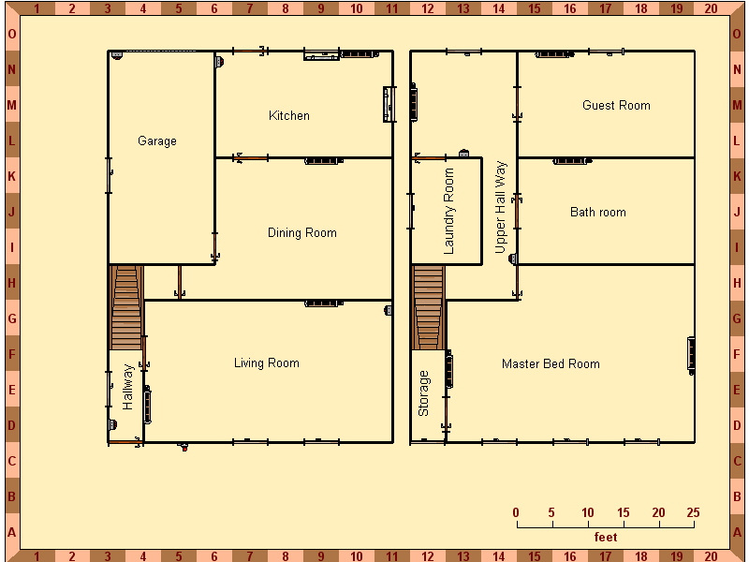

This is a simple two up two down terrace house in London 35 minute walk from Pegasus Systems. It has a very basic alarm system (security systems check at – 15 to bypass) the only two pieces of modern technology in the house is a top range stereo system and a cordless phone. The house smells of his cat Spike. He has a lot of old books covering many subjects most of which are first editions and a massive collection of old blues records and goon show albums.
There are no plans or information about the Hydra weapon system in his house. Has £2.700.95 in his account and a safe-deposit box in the same bank.
Kingston’s rota for the next 7 days

Pegasus Systems

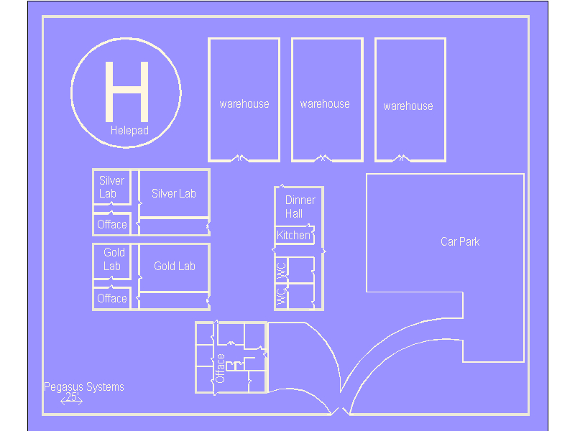

A purpose built facility on the outskirts of London composing of 7 buildings (3 stores buildings, 2 R&D buildings, 1 Administration building, 1 changing room and dinner hall). Onsite security is run by Free Fall Security services, Mr Davis Kelly an ex US Navy Seal is in charge of onsite security.
Security has 3 layers (gold, silver and bronze)
- Gold level upper management, top scientists and select security officers only.
- Silver Level mid level executives, remaining security officers and cleaning staff.
- Bronze Level casual workers, catering staff and unchecked visitors.
Every door is coloured with the pass level, each section has a x-ray device and metal detector so that anyone who passes is given a full check. (¼ computer check or ⅛ INT check on the mainframe to find a sleeper program to down load data onto a USB memory device)

Gorgeous Bodies Fitness Centre

No map

A new purpose built fitness centre on the ground floor, it has a swimming pool, restaurant and offices. On the two upper floors are the gymnasium and work out rooms. The gym is currently looking for new fitness instructors and is owned and managed by Peter D Queen. If the players break in to the office and search the files (INT check) they find the member pass for Angelina Rodrigo under the name of Annie Smith. Dated 11 months ago.

Shore Antiques

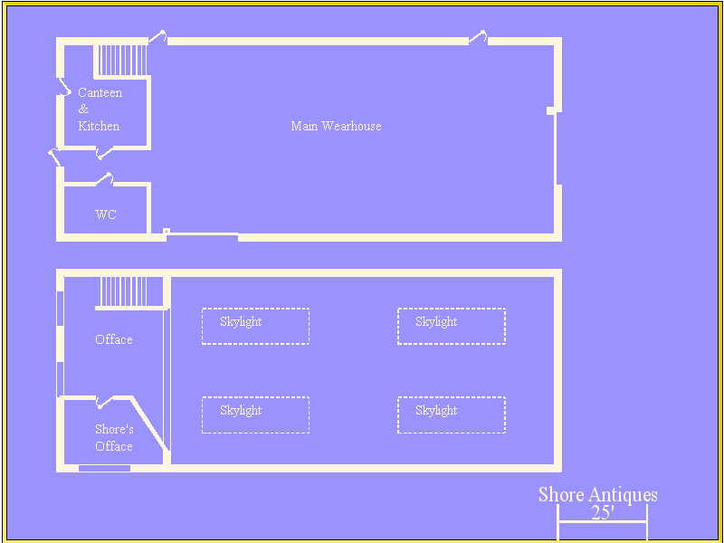

A old warehouse in the east end of London serves as a show room, auction room and living space for Rupert Henshore. The basement is flooded and sealed off. In his office in a file draw under the letter b there is a Browning High Power 35, 1 clip. In the safe there are two sets of account books, also in the office there is a small PC running Windows 95. This contains his personal address book and diary. If players go in at night they have a 45% chance of disturbing Rupert in the office. The building is protected by a 3 stage alarm system requiring 2 full checks and 1 half check on security systems to bypass. All the locks are of very good quality – 45% to pick.

House Paris

No map

The old 5 story town house is the Parisian front for the smuggling ring. On the ground floor there is a 5 car garage; two BMW sedans, an Austin Martin DB5 and a Range Rover. The first floor houses O’Connell’s security force of 18 men all ex foreign Legion,
The entire building is under constant surveillance with CCTV on every floor. Alarms are on every window and door with 2 men monitoring at all times, all security force are armed with H&K USP .45ACP side arms at all times and have access to the armoury of 6 H&K MP5K SMG’s, 4 H&K G36K Assault Rifles with 40mm Grenade launchers, 2 H&K PSG1 Sniper Rifles, 6 Remington 870 shotguns, 20 40mm HEDP, 20 40mm stun, 18 sets of night vision goggles . All guards wear load bearing assault vests at all times.

The Argentine Shipyards

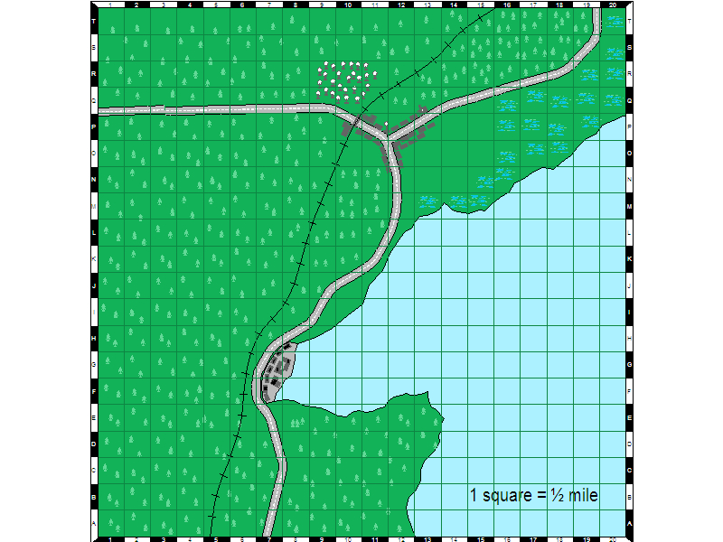

The shipyard is located in a remote costal area facing the Atlantic Ocean. There is a local train station with a rapid response police force that can deploy in 45 minutes. They have 3 trucks in the local town. The land west of the train track is heavy wooded and marsh land to the north.

The ship yard is split into 4 sections: Construction, Stores, Research & Development and Administration. Antonio Rodrigo lives in a penthouse apartment on the top floor of the Administration building. On site security is covered by a private security force, all military trained and are equipped with the latest in Russian equipment and weapons. Total force of 120 men; 40 men only on duty at a time the rest live in the local town 20 minutes drive away. The security force are currently installing a new parameter security system which has set off several false alarms in the past weeks so there response time will be slow.
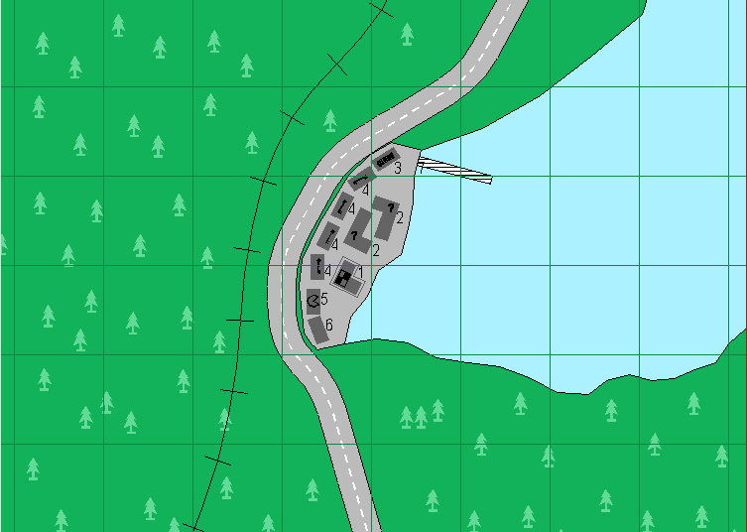

1, Administration Building
9 stories tall on the 8th floor they are working on a prototype of the Hydra

2, Research buildings (2)
These buildings are three storeys tall with a complement of 12 security personnel each, working on building an experimental assault rifle in 6.8mm.
Rifle stats NAME Diablo DAO-06 6.8mm , WT 9 lb, Damage 1D6+1, RANGE 170/600/1900, AMMO 60 (snail mag ), Reload 3C, NOTES: very high rate of fire, bulpulp configuration, integrated UV laser sight and variable power UV scope 3-24X50 magnification

3, Chemical stores
A large warehouse has loads of industrial chemicals

4, Stores
4 warehouses all with independent intruder alarm systems.

5 dining hall
Houses a kitchen dining hall locker rooms and showers

6, fuel tank 120 feet high stores diesel for ships (would make a lovely bang)

7 Submerged Runway
a semi submerged runway and waterproof hanger under the main base housing 2 C130 Transport aircraft, 1 AC130 Spectre Gunship, 3 transport helicopters, 1 reconditioned Spitfire, a reconditioned Messerschmitt 109 and a partly rebuilt Japanese zero. Access to the hanger can be made from any building on the ship yard so long as you pass the palm scan security system, if trapped Antonio will head for the hanger and one of the fighter plains to make his escape and set off the tactical nuclear device under the shipyard.

Name: Angelina Delgado (Rodrigo)
Organisation/ Occupation: Free lance intelligence operative
Security Clearance: Unknown
Known Alas |  | Date of Birth: | 1/9/76
Angela Price |  | Nationality: | Argentine
Annie Smith |  | Eye Colour: | Brown
Annabel Purdue |  | Hair Colour: | Dark Brown
Ann Robinson |  | Weight: | 101 pounds
 |  | Height: | 5 feet 5 inch
Personal History
Date and Location | Notes
1994 Argentina | Won the Miss Argentina Beauty Pageant
1995 Argentina | Joined the Argentinean army as part of a recruiting drive.
1996 Argentina | Attached to the Military Intelligence Division.
1997 Argentina | Met and married Antonio Rodrigo (it has been suggested that she was ordered to spy on him by Argentine intelligence)
1998 France | Photographed in Paris, France meeting with the Parisian Mafia Boss Don Henri Deckard (deceased) using the alias of Annabel Purdue two days later Henri Deckard was killed in a shooting accident. It is suspected that Angelina Rodrigo replaced the propellant in one his shotgun cartridges with an amount of Astrolight A1.5, resulting in blowing Deckard’s head off.
1999 Argentina | Mike Santiago of the Argentine intelligence division is found dead in the following 12 hours 7 of his case officers all die in freak accidents Angelina Rodrigo disappears suspected to have joined T.H.R.U.S.H.
2000 world wide | Several sightings of Angelina Rodrigo in Australia, New Zealand, South Africa, Germany and United States Of America each time she lost the agents perusing her.
2001 – 2006 unknown | No sight of her however rumours persist that she has left T.H.R.U.S.H. and is working freelance possibly for her husbands business interests
Known affiliations | Known talents and recourses
Antonio Rodrigo | Social chameleon, Disguise, Intelligence gathering, Unarmed combat expert,
Rupert Henshaw III | Kendo Master, Contact Development, Foreign language and customs.
Henri Deckard
Gerald Kingston PHD

Name: Antonio Rodrigo
Organisation/ Occupation: Multi Millionaire Businessman
Security Clearance: None
Known Alas |  | Date of Birth: | 1/4/1970
Anthony Johnson |  | Nationality: | Argentinean
 |  | Eye Colour: | Blue
 |  | Hair Colour: | Black
 |  | Weight: | 201 pounds
 |  | Height: | 6 foot 1 inch
Personal History
Date and Location | Notes
1980 Argentina | At the age of 10 Antonio’s father was killed in the Falklands conflict he spent most of his youth growing up with a variety of guardians
1988 England | Arrived in England and using his family’s wealth arranged a false identity for himself he then joined the Royal parachute regiment as a Trooper.
1991 England | Thanks to generous bribes in the right places Trooper Johnson was given a commission and sent to Sandhurst making friends with Rupert Henshaw III
1993 England | Resigned his commission stating conflict of personal interest, he then returned to Argentina to save his failing family business
1995 Argentina | Rodrigo shipping and transport becomes one of the richest companies in the southern hemisphere
1997 Argentina | Met and married Angelina Delgado (it was suspected that Angelina was ordered to get close to Antonio by Argentine Intelligence)
1997 Argentina | Met and married Angelina Delgado (it was suspected that Angelina was ordered to get close to Antonio by Argentine Intelligence)
2000 Argentina | Rodrigo Mining group discover large deposits of diamonds in the Argentine Mountains after fixing a deal with the government Rodrigo holdings becomes the 5th richest company in the world and starts developing telecommunications, avionics and many other useful technologies. Bring jobs and wealth to people.
2002 Argentina | Rodrigo Munitions inc. formed with the intent of rebuilding and reequips the Argentine military.
2004 Argentina | The Rodrigo ship yard starts building two oil platforms all with weapon mounts. They also start building the world biggest cruise ship and 2 support vessels both bigger than any transport to date
Known affiliations | Known talents and recourses
Rupert Henshaw III | Hand to hand expert, Weapons expert, Heavy weapons expert,
Angelina Delgado | Fencing Master Ciphers and codes Parachute trained
 | Fixt wing pilot Rotary wing pilot has collection of World War II planes

Name: Dr Gerald Kingston PHD
Organisation/ Occupation: Research physiatrist
Security Clearance: Pegasus Systems –Gold--
Known Alas |  | Date of Birth: | 25/12/1945
 |  | Nationality: | English
 |  | Eye Colour: | Hazel
 |  | Hair Colour: | Grey (receding)
 |  | Weight: | 153 pounds
 |  | Height: | 5 feet 5 inch
Personal History
Date and Location | Notes
1945 England | Born in Sidcup Kent
1963 England | Started working for Pegasus systems
1986 England | Had a small win on the pools and used money to purchase his house
1996 England | Began work on project Hydra as lead researcher
2006 England | Photographed in a Starbucks meeting with Angelina Delgado and Rupert Henshaw III
Known affiliations | Known talents and recourses
Angelina Delgado | Doctorate in Physics
Rupert Henshaw III | He has £5,080.00 in his bank account with Lloyds TSB, owns his own house

Name: Liam O’Connell
Organisation/ Occupation: Parisian gangland Enforcer
Security Clearance: None
Known Alas |  | Date of Birth: | ??/??/1962
Liam Devilin |  | Nationality: | French
Lee Connell |  | Eye Colour: | Black
Liam Fitzpatrick |  | Hair Colour: | Black
 |  | Weight: | 158 pounds
 |  | Height: | 5 feet 7 inch
Personal History
Date and Location | Notes
1977 Northern Ireland | He killed a school friend after an argument over a football match
1979 Northern Ireland | He was recruited by the IRA and spent 10 years learning their trade and doing jobs for them he excelled at car bombs.
1989 Northern Ireland | He and 4 probationary members of the IRA kidnapped two off duty members of the parachute regiment. In the two days that followed he tortured them for information finally when he had enough info he got one of the new boys to video him kicking the 2 troopers to death. The video was then sent to the BBC and ITN news with the message that this will happen to any British soldiers he found in Ireland. Within 24 hours the IRA had kicked him out of Ireland on threat of death.
1990 various countries | He began working as a mercenary in Africa and the Far East
1995 France | He finally settled in Paris working in the underworld first as a hit  man then as part of an international smuggling ring.
Known affiliations | Known talents and recourses
I, R, A, (now thrown out), | Expert unarmed combat, small arms, explosives

Rupert Henshaw III

Name: Rupert Henshaw III
Organisation/ Occupation: Antiques dealer, head of smuggling ring
Security Clearance: None
Known Alas |  |  | Date of Birth: | 7/7/1968
Rupert Shaw |  |  | Nationality: | English
 |  |  | Eye Colour: | Grey
 |  |  | Hair Colour: | Blond
 |  |  | Weight: | 190 pounds
 |  |  | Height: | 6 feet 1 inch
Personal History
Date and Location | Notes
1968 England | Born in Knightsbridge to Lord Rupert Henshaw II received an education at Harrow gaining a degree in art history
1991 England | Joined the British Army received training at Sandhurst where he first met with Antonio Rodrigo, rumours around this time suggest that Rupert was involved with several money making scams.
1992 England | Joined the Royal Logistics’ Corps
1996 England | Given a Dishonourable discharge after being caught selling MOD property namely selling Diesel to local haulage companies
1998 England | Started Shaw Antiques he also started frequenting the Golden Nugget Casino
2000 England | Set up a people smuggling ring basing it in Paris using a local gangster called Liam O’Connell to enforce and protect his interests
2001 England | Having a bad run at the casino Rupert now owes 200,000+ to a local Yardy gangster called Jonnie Diamond, and starts smuggling drugs in for him
2006 England | Photographed in a Starbucks meeting with Gerald Kingston and Angelina Rodrigo
Known affiliations |  | Known talents and recourses
Liam O’Connell |  | Unarmed Combat, Pistol shooting (expert), Photographic Memory
Antonio Rodrigo |  | Lighting Calculator, Antiques expert, Language expert
Angelina Rodrigo
Jonnie Diamond

Gerald Kingston

AGM-119A Hydra Sea Skimming Anti ship missile

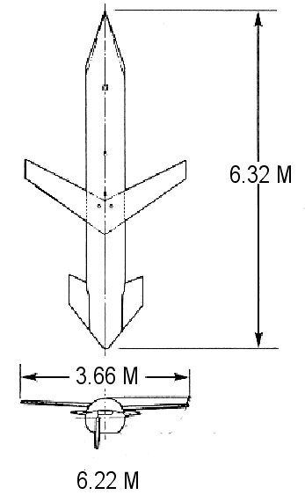
Dimensions
With wings and tale plane deployed
Length: 6.32m (20.7 ft)

Body Diameter: 6.22m (24.5ft)

Span: 3.66m (12 ft)

Launch weight: 1,282 kg (2,825 lb)

Propulsion: One Pegasus Systems KA-666 Turbo fan Engine

Range: Max range 911 miles (variable on weather conditions)

Flight speed: Cruse speed Mach 0.70 (terminal phase see development)

Warhead: loaded with 5 independent targeting high explosive
Warheads each loaded with a 45.3kg (100lb)
Shape charged thermion nitrate super penetrating warhead

Delivery Cost: £700.00 per unit

Development:

The Hydra weapon platform is designed to fit any existing aircraft capable of launching an ALCM AGM-86B (Cruise Missile). It is designed to loiter over a target area on sentry duty until its control aircraft locates a hostile target or the target enters a preset threat area. The missile then launches one or more of its five independent warheads. Each warhead accelerates towards the target tracking in on it’s own path utilising a new highly advanced FLILR (Forward, Looking, Infrared, Laser, Radar) system to plot its course and identify the target, with its sea skimming at a speed of Mach 2.5 and super stealth coating makes the sub munitions warheads virtually untraceable by even the most modern ship mounted defence systems.

Upon striking the target ship its super penetrative warhead can blasts through 30 feet of steel in less than a tenth of a second, Causing secondary damage by super heated gas cloud burning any soft targets in the area.

In an attempt to make the weapon system more wildly available Pegasus Flight Systems have reconfigured a C130 Hercules, (now designated BC130X) to serve as a launching platform and airborne control station, the rotating missile rack can hold up to 6 missiles at the same time. They launch by dropping them out of the back loading ramp with the use of a drag chute.

