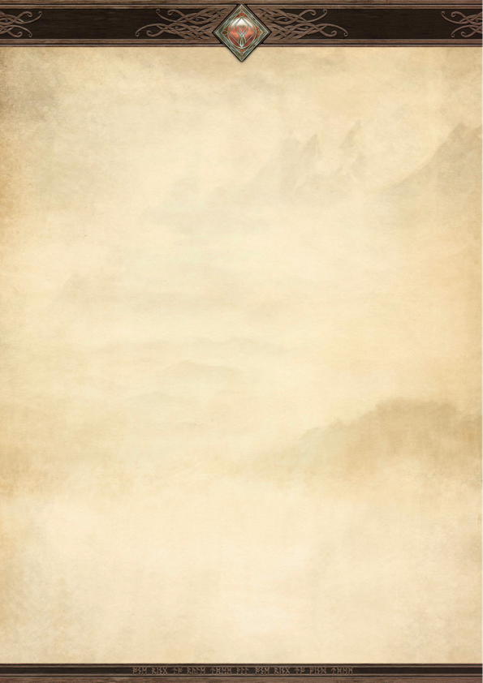
Contents (font: livingstone, size: 36)

Main Titles (font: aniron, size: 20)

secondary titles (font: dumbledore, size: 16)

Main text (font: Alois, size: 10) with bold headings where necessary

