A game of dynastic conflict by Derek Carver

INTRODUCTION
Blood Royale is a game of treachery, double-dealing, power-politics, dynastic aggrandisement and open warfare, set in the world of 14th century Europe. It is a strategic-level political 'wargame', with a high level of player interaction, and almost unlimited scope for co-operation and deception, alliances and treachery. It is also similar to conventional boardgames, whereby players can pursue objectives based on trade, finance and planning. Since the game is played out with individual characters, it is even a game of roleplay ing, with each player representing the abstract concept of a Royal Dynasty.
Each player's object is to increase the power of his realm and his exchequer, and to secure his Dynastic line. This is done by trade, military adventuring, and by arranging marriages for his children.
Blood Royale has been designed to be played by beginners and experienced players. The Basic Game
introduces most of the concepts which govern the way Blood Royale is played, and allows players to quickly come to grip with the rules. The Optional Rules present some ideas for ways in which the game might be built on, allowing for a greater level of complexity. Many players will be able to develop further ideas of their own.
3 to 5 players can play Blood Royale. Most games will last from three to four hours, with each turn representing a five-year period lasting about half an hour. However, if the players choose, they can make the game last for as long as they like.
Blood Royale is not a wargame as such. Although conflict is a permanent feature, combat is normally restricted to skirmishing rather than all-out war. As was the case during the period in which the game is set, the most successful countries will be those who fight small, short wars to achieve specific goals... and win them.
Neither is Blood Royale a simulation. The game is intended to have the 'feel' of 14th century Europe, but the countries depicted conform to their present-day appearance, rather than to the actual geography of the time, and the divisions of each country have been simplified. Also, the very nature of the game means that players will not be playing the actual characters of the period. So - be warned; both history and geography have been tampered with!



THE BASIC GAME
(1) Game Equipment 3 The Map 3 The Playing Pieces 4 Money 4
(2) Setting I p The Game 4
(3) Winning The Game 5
(4) The Sequence of Play 5
(5) A Full Game Turn 5
(6) The Dynastic Sequence - Birth 6 Character Sheets 6 Effects of Characteristics ~* I'sing The Prince Pieces 7
C⁷) The Dynastic Sequence - Death ^
(8) The Dynastic Sequence -Marriage 7 Marriage Contracts 8 The Effects of
Characteristics 8 Marriage and the
Succession 8 Marriages and Children 9
(9) Succession 9
Female Succession 9 Disputed Succession 10 Penalties For Passing Over
A Legitimate Heir 10 Controlling Two
Countries 10 Procedure In The Case Of A
Minor Ascending The Throne 11
(10) End Of Dynastic Sequence 11
(11) The Interphase - Taxation 11
(12) The Interphase
- Placing Resources 11
(13) The Interphase - Maintaining and Raising Armies and Fleets 12
(14) The Movement Phase - Player Order 12
(15) The Movement Phase - Events 12 Event Table 12 Effects of Events 12 Random Provinces Tables 13
(16) The Movement Phase-
Movement 13
Armies, Kings and Princes 13
Fleets 14
Resource Items 14 (I"⁷) Controlling Provinces 14
(18) Capitals 15
(19) Combat 15
Effects of the Presence of
Royal Pieces 15
Fleeing From Battle 16
Retreats 16
Surrender 16
Captured Royal Characters 16
Capitals 16
To The Winner The Spoils 16
Alliances 16
Naval Combat 16
(20) Negotiations 16
Foreign Intervention 17
(21) Cashing-In Resource Items 17
(22) Ending The Game 17
(23) Special Rules For Less Than Five Players 18
Combat With 'Non-Player' Countries 18
(24) The Degree of Secrecy In The Game 18
(25) Special Rules and Advice For The Beginning Of The Game 18
OPTIONAL RULES
(A) The Four Character Start 19
(B) Characteristic Rolls For The King And Queen 20
(C) Disputed Succession 20
(D) Movement of Trade Items 20 (E) Event Cards 20
Shuffling The Pack 20
Rebellions 20
Storms 21
Bidding and Investing 21
Inheritance of Neutral
Provinces/Kingdoms 21
Fighting Neutrals 21
Pretenders and Bastards 21 (F) Neutral Provinces 22 (G) Governing Provinces 22 (H) Extra Event/Movement Phase 23 (I) Changing Capitals/Resource Areas 23
Design Notes - The Optional Rules and Strategy Hints 23 Some Tips For Naming Dynasties and Characters 24

COMPONENTS
Example 1=
It is the 1335 Turn. In the 'Year Ending- 0'box are 8 Amy counters, and in the 'YearEndings' box are 4 Army counters. During the Interphase of the 1335 turn the 4 Army counters in the 'Year Ending- 5'box are returned to the respective playersforce pools.
In the Movement Phase of the 13351\am a total of 12 Army counters are lost due to combat. These are placed
Ending - 5' box on the mapboard. They will return to the players force pools at the start of the Interphase of the 1345 turn.
Within this box you should find the following components:
A six-piece, jig-cut playing board, showing a map of Western Europe, and additional game information.
1 King piece for each country (five in all) 5 Prince pieces for each country (twenty-five in all) 20 Army counters for each country (one hundred in all) 4 Ship counters for each country (twenty in all). One sheet of 30 stickers
These playing pieces and counters are colour coded for the different countries: Green (England), Purple (Italy), Yellow (Spain), Blue (France) and Orange (Germany).
I Fifteen 'metals' resource counters
Fifteen 'cloths' resource counters
Fifteen 'foodstuffs' resource counters
Ten semi-luxury resource counters
Five luxury resource counters
12 Famine Markers
18 Rebellion Markers 25 Control Markers 15 Neutral Markers (Optional rules) 2 Mercenary Captain counters (Optional Rules) 10 Neutral Army counters (Optional Rules)
1 Year Turn Marker
5 Player Order counters
96 coins, in the following denominations: 4x 50 Crowns, 12x 25 Crowns, I6x 10 Crowns (silver) 24x 5 Crowns, I6x 3 Crowns, 24x 1 Crown (bronze) A pad of 100 Crown notes
A pad of character sheets A pad of Marriage Contracts
One pack of 63 Event Cards (Optional Rules) 4 dice - 3 six-sided dice, and 1 ten-sided dice
This rulebook...
You will certainly find it useful to have a supply of scrap paper and some pens or pencils handy. Some record keeping is necessary in this game.
Copyright © 1987 Games Workshop Limited
If any components are damaged or missing please write to: Blood Royale, Games Workshop, Chewton Street, Hill Top, Eastwood, Nottinghamshire NG16 3HY, and indicate which components are missing or damaged.
Questions about this game will be answered by Games Workshop if accompanied by an A5-sized, stamped, self-addressed envelope or 2 international reply coupons. Questions must be typed or legibly printed. Please try to ask your questions in such a way that they can be answered 'yes' or 'no', or so that they can be answered with a short reference. Although we welcome andenjoy comments and suggestions about the game system, we cannot promise to respond to questions on theory or design intent.
CREDITS*
Invented by: Derek Carver
Development: Paul Cockburn, Jervis 'You've got me drunk again' Johnson
Art and Illustration: Stephen Dukes (board an), Dave 'Super Star' Andrews & Colin 'Cavalier' Dixon (counter art)
Graphic Design: (everything else) Charles 'Dewbury' Elliott and Bil 'Gobbledigook' Sedgwick
THE BASIC GAME
(1) Game Equipment The Map
The playing surface of Blood Royale is a map representing Western and Central Europe, showing the countries of England, Spain, France, Germany and Italy. The border of each country is depicted in a particular colour, as follows:
Green England
Yellow Spain
Blue France
Orange Germany
Purple Italy
Each country is divided into ten provinces. These provinces affect many parts of the game. Control of a Province is governed by the rules in Section 17. Certain Provinces carry an additional marker, which will be one of the following:
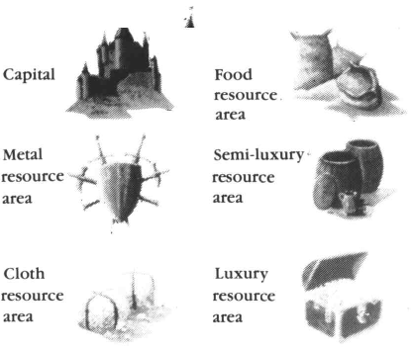
Each Capital serves as the location of the Dynastic court, and as a castle (see Capitals (18)). Each resource area is the source of the relevant resource, which will be produced each turn for the purposes of trade (see Placing Resource Items (12)).
The Turn Record Chart
The Turn Record Chart serves two functions ; first it shows which year the current turn is, and second it is used to store Army counters that have been removed from the map due to combat or plague.
The Year Track Marker should be placed on the year coloumn, so that the current turn's year is showing just above it. At the end of each turn, it should be moved down the coloumn so that the year for the next turn is showing.
Army counters that have been removed from the map due to combat or plague are not available to be rebuilt during the next turn, players will have to wait 10 years before they can replace these loses. To keep track of which Army counters cannot be rebuilt players should use the Dead Army Counters boxes on the map-board in the following manner:
At the start of the Interphase any Army counters that are in the box with the 'Year Ending' number corresponding
box and placed beside the gameboard.
During the Movement Phase, any Army counters that are removed from the map are placed in the box with the 'Year Ending' number corresponding to the last digit of the current turn, (see example 1)
The Holy Landbox is only used with the Optional Rules, ignore it when playing the basic game.
The Playing Pieces (See Note I) Money
,Vnte.-1———
The Capital, Mercenary Captain and Neutral Army are not used in the Basic game. Some of the resource items have a black background. These should not be treated differently in the basic Game. The background distinguishes these Resource Items for use with Optional Rule (I).
The Dice:
Blood Royale includes 3 six-sided dice (numbered 1 to 6) and 1 ten-sided dice (numbered 1 to 10). The ten-sided dice is only ever used when rolling on the Ramdom Province Table
Note 2——
If there are less than 5 players, the rules in Section 23 should be read before play stares.
Certain playing pieces are colour-coded, and can only There are two types of money in the game; plastic
be used by the player running that country: coins and paper notes.
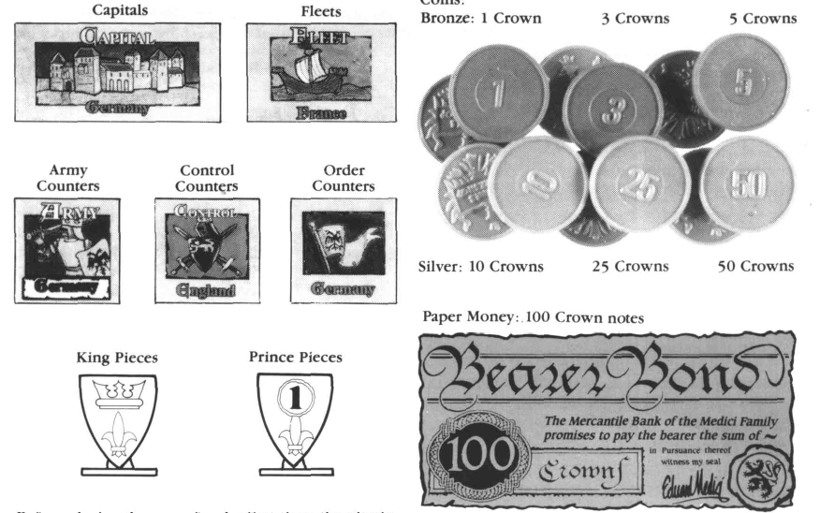
Before playing the game for the first time, the plastic pieces need to have their stickers affixed. Each set of six identically-coloured plastic pieces has a set of six stickers, marked 'K' and '!', '2', '3', '4' and '5'. Peel the stickers off the backing sheet, and fix to the plastic pieces.
The remaining pieces are usable by any player:
The use of the various game pieces will be described in the relevant sections of the rules.
(2) Setting Up The Game (See Note 2)
Each player controls a country and a family Dynasty. To begin the game, each player should select the country he controls. This can be done by any agreed method, although the simplest things is for each player to draw one King piece from a cup or other container, and to take that country. You can then place the King piece in the capital.
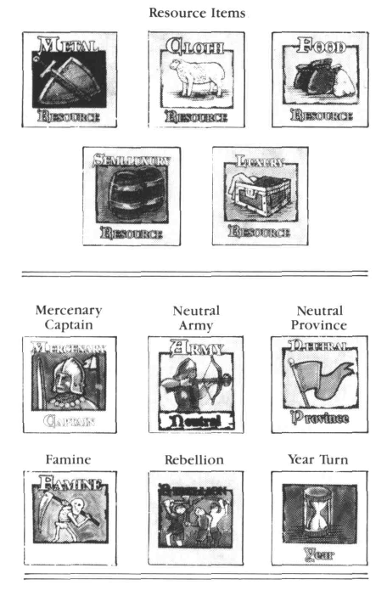
Place the playing area on a suitable surface, and arrange the players so that each is sitting conveniently for the country he or she controls.
Each player should then take the other colour-coded pieces for the country they control, and place them conveniently to hand in front of them (if this is the first game with this new set, you will need to place the stickers on the playing pieces; each country should have one King 'K', and 5 Princes '1-5'.)
The Year Turn marker should be placed in the 1300 box on the Year Track. The other counters and the Marriage Contracts should be placed somewhere close to hand. Ignore the Event Cards and the counters from the Advanced Game.
Place the money in a convenient place to one side of the board. This money forms the bank or Treasury, into which payments will be made for players' Armies, Fleets, etc, and from which they will draw revenue.
Each player will require three characters to begin the game with. These characters will be recorded on the Character Sheets provided. The three starting characters in each Dynasty are:
A King aged 25 (born in 1275)
A Queen aged 20 (born in 1280)
One child, aged 5 (born 1295). The child's sex
should be determined by rolling a die: on a result of
1-3 the character is male, on a 4-6. female.

Fill out the character sheets as in the example that follows. You will have to choose a Dynastic name for your family and Christian names for all the members of the family (there are some suggested names at the end of these rules). Each character must then be given the three Characteristic ratings. For the King and Queen these can be regarded as Normal. For the child, you must establish the characteristics by rolling three dice, three times, and comparing the result to the following table:
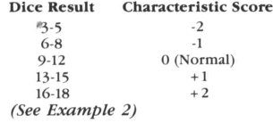
(3). Winning The Game
Before the game starts, players should decide how long it will last. You can either play for a set period of 'real' time (eg, three hours), or for a set period of 'game' time (measured in units of five years). As a guide, each five year turn should take about 20-30 minutes - although your first game is bound to be much slower than this.
At the end of the game, the player with the most money wins. A final cashing in of resources is allowed after the last turn (see Ending The Game (22)).
If you wish to play a sequence of games, each following on from the last, each player should record the amount on money he or she has at the end of a session, and the winner of each session will then be the player who has increased his or her wealth by the greatest percentage.
(4). The Sequence of Play
A) DYNASTIC SEQUENCE: Births Survival Marriages Announcements
B) INTERPHASE Taxation
Placing Resources Removing Famine counters Removing Rebellions by payment Maintaining Forces Raising Forces
C) MOVEMENT:
Event *
Movement
Event
Movement
(Event)
(Movement)
D) CASHING IN RESOURCES
(5). A Full Game Turn
A: Each game turn start with the Dynastic Sequence.
First, players will establish whether any children have been born to marriages in their Dynasty. If this happens, aCharacter Sheet should be created for the new character (see Birth (6)).

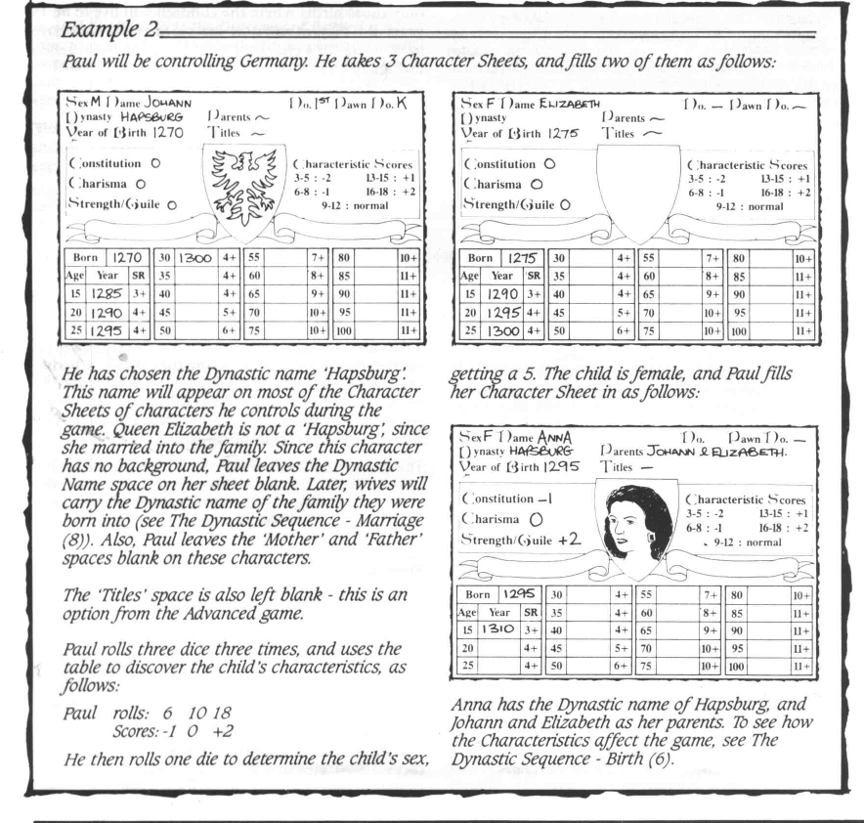
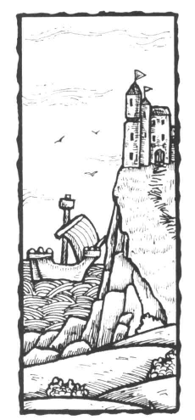

Also, players will need to see if their characters survive the turn, by making a Survival Roll (see Death). Characters who fail this roll are removed from the game. Should a reigning monarch die, his/her successor will ascend the throne (see Succession (9)).
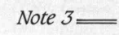

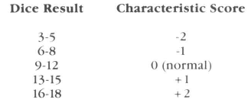
If more than one child is bom to the same parents during the same year (ie, the player makes additional Birth Rolls), the Year of Birth space on the
character sheet of the second child should be filled in with a date one year later than the current turn (ie, 1301 in the first turn, 1306 in the second, etc), and a third child's Year of Birth should be two years later. This is
important when it comes to determining Succession to the Throne.
Unlike the Year of Birth space, the Year Track should only carry the dates of successive game turns. Thus, for the second child born to a married couple in the year 1320, the player would write 1321 in the Year of Birth space, but 1320, 1325, 1330 and 1335 in the first four spaces of the Year Track.
Third, players arrange marriages for their Dynasty's children (see Marriages (8)). Characters cannot actually marry until they are 15 years old, although marriages can be arranged for them at any time - even before they are born!
At the end of the Dynastic Sequence, players must Announce the events that have occurred within their Dynasty. They must give a verbal report to all the other players of the Births, Marriages and Deaths (including the succession of any new rulers), so that players who were otherwise occupied with their own affairs will know what is going on. At this point, any widows (except Queens) are returned to their original ruling house (see Deaths (7)). Players should also announce the Characteristic Scores for new characters born that year. These scores are never secret, and should be revealed for other characters if requested.
B: There follows the Interphase. This comprises:
1. Taxation
2. Placing of New Resources
3. Removal of Famine Markers
4. Removal of Rebellion markers at a cost of
15 crowns per province
5. Maintaining existing armies and fleets
6. Raising new armies and fleets.
During the first turn only items 1, 2 and 6 apply.
As with the Dynastic Sequence, all the players can perform these actions at the same time, although each player must go through points 1-6 in the sequence in order (taxation, raising new resources, removal of famine tokens, removal of rebellion tokens (optional), maintaining armies/fleets, raising armies/fleets).
C: Then come the Movement Turns. These should take place in the following order:
1. The 5 Player Order markers should be placed in a cup or similar container, and a player should draw one, and show it to the other players. The country indicated by the marker will play through the Movement Phase first.
2. The player of the country- revealed by this draw then rolls one dice, and compares the result to the Events Table (see Events (15)). The Event occurs immediately.
3. The first player takes his or her turn to move and resolve any attacks (see Movement (16) and Combat (19)).
4. The first player then draws another
Player Order Marker from the container, to establish the second player (the drawn Markers should be placed to one side until they have all been drawn). The second player then takes his or her turn to move and resolve combat, and to draw the next Player Order Marker. This continues until all players have taken a turn to move and resolve combat.
5. The Player Order Markers are then
returned to the container, and steps 1-4 should be followed through a second time, with the first player making the roll for Events, and each player taking a turn to move and resolve any combats.
In a 3-player game, players should repeat steps 1-4, for a third round of Events, Movement and Combat.
D: The Full Game Turn ends with Cashing In Resources (see Ending The Game (22)
(6). The Dynastic Sequence - Birth
Each Player rolls two dice for each married couple in their Dynasty. On a result of 7 or higher, a child is born in that Year Turn.
During the Dynastic Sequence, players have the chance to increase the size of their Dynasties through births. Each married couple controlled by a player is capable of producing children, so long as the female partner is 50 years old or younger (although Birth rolls should not be made if either partner is being held prisoner).
Each five-year turn, during the Dynastic Sequence, each player with married couples within his or her Dynasty may make Birth Rolls for each wife aged 50 years or younger. To discover if a birth has taken place within that marriage, the player should roll two dice. If the result is 7 or more, a child has been born.
The player may then make up to two more additional die rolls for each married couple (regardless or not their first die roll was successful). Each of these additional rolls takes one point away from the wife's Constitution Characteristic (see below) for that 5-year turn only. In other words, excessive child-bearing lessens the mother's chance of survival.
The births generated by this process do not represent all the live births a female character has during her life, since a great many children born in the 14th Century did not survive to become adults. This process represents only those births where the children will live to be 15 years old. Players will note that no Survival Rolls have to be made for a character until he or she has reached the age of 15.
Character Sheets
For each new character brought into the game, the player must fill out a character sheet.
As explained under Setting Up (2), three character sheets have to be made out to start the game. Each time there is a birth, the controlling player must also make out new character sheets for these new characters.
To explain the procedure fully we will describe the making of a Character Sheet for a newly born child. Having made a successful Birth Roll, the player should then roll a single die to establish the sex of the child. On a result of 1-3, the new character is male, and on a 4-6 result, the character is female. Players may make this sex determination die roll before they decide whether or not to make additional Birth die rolls (see above - a family producing too many girls might choose to make an extra effort in the hope of producing a boy to ensure a trouble-free Succession).
The player should then roll three dice three times to generate the Characteristics for the new character. Compare the resulting dice score to the following table to find the Characteristic scores for Strength/Guile, Constitution and Charisma.
The character sheet can then be completed, as follows:
YEAR OF BIRTH: This can be filled in with the date of the current turn (ie, 1300 for the first turn, 1305 for the second turn, etc) as indicated by the turn track (See Note _i)

BORN: The top box on the Character Sheet's year track should be filled in with the year of the current turn (1300 in the first turn, etc). Each successive box underneath should be filled in with the year of successive turns (1305, 1310, 1315 etc), at least up until the year in which the child is 15. As the character ages, additional dates should be filled in as required. (See Note 4)
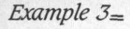
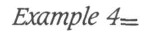
Mathilde (-2 Guile) marries Francisco (-1 Strength). Francisco is now effectively -2 in combat. The Spanish player now has an even more useless war-leader - so there had better have been some good reason why he married her in the first place...
A mother aged 30 needs 4 or more to survive. She started with a Constitution of+1, but has made two additional attempts to produce children, reducing her Constitution for that turn to -1. The player rolls 7, which is modified to 6. She has rolled higher than the required 4, and so survives.
Survival rolls are not required for children bom that turn, nor for children aged 5 or 10. Characters automatically survive to the age of 15.
If you are beginning players, it is advised that you do not make Survival Rollsforyour King until the 1310 turn at the earliest. This will avoid the slight possibility of a King dying in the first turns, whilst you are still mastering the basic routines.
SEX: As determined above.
NAME: Each child must be given a Christian name of the player's choice
DYNASTY: Write the name of the father's Dynasty, followed by the mother's and father's names. A child will normally carry the father's Dynastic name, although the children of a female character who is a Queen in her own right will carry her Dynastic name.
TITLE: This space is not used in the Basic Game.
CHARACTERISTICS - Strength/Guile, Constitution, Charisma: As determined above. The importance of the different characteristics is explained below.
PRINCENUMBER: This refers to the playing piecewhich is used to represent a male character when moving about the board. It should read either 'K' for the King, or be numbered 1- 5 to match one of the playing pieces for that country. It should not be filled in when the child is first born, but only when a male child reaches the age of 20.
When a royal male character reaches the age of 20, he must be placed on the board in a Home Province, using one of the numbered Prince pieces (see Using The Prince Pieces, below). He can subsequently be moved, and can command Army counters in battle.
Effects of Characteristics
Strength/Guile affects the Outcome of Battles Constitution affects the length of time characters will live in the game. Charisma affects Rebellionsandbrings cash rewards/penalties for female characters in marriage
STRENGTH/GUILE: Boys have the former and girls the latter. This affects a male character's performance in battle (sec Combat (19)) His wife's rating is added to (or subtracted from) his. Since characters can never be rated higher than + 2 or lower than-2, if a wife's score would modify the husband's score outside of this range, the excess is ignored. (See Example 3)
CONSTITUTION: This affects the character's chances of Survival. A -2 score means that the character is unhealthy whilst at the other end of the scale + 2 means that the character is healthy and should be long lived (see Death (7)).
CHARISMA: This represents the character's popularity. A 2 means that rebellions arc most likely wherever that character goes, whereas + 2 implies popular support and far less chance of rebellions (see Events (15)).
In addition, if Brides have a Charisma score of +1, their husband's Dynasty will receive 30 Crowns from the Treasury at the time of their wedding (this becomes 60 Crowns if the bride is + 2). Conversely, a character marrying a girl with -1 Charisma will cost his Dynasty 30 Crowns (which becomes 60 Crowns for a -2 score sec Marriage (8)).
Using The Prince Pieces
As stated above, whenever a male character in a Dynasty reaches the age of 20, the player should place a Prince piece on the board in a Home Province. The player should record the Prince Number on the playing piece on the Prince's Character Sheet
It there are already five Prince playing pieces of that Dynasty on theboard, the 'new' Prince cannot be placed on the board That character remains in the capital, and may not be moved. If a King or Prince dies and a play ing
piece is freed, the oldest Prince not represented by a piece should now use the one that has been freed.
If a Prince character of one Dynasty becomes controlled by the player of another Dynasty (because of a Marriage Contract or the play of an Event Card), his playing piece should be swapped for one of the 'new' Dynasty, and the change in the playing piece recorded. If there is no free playing piece of the 'new' Dynasty, the character cannot be represented on the board, is assumed to be moved to the 'new' Dynasty's capital, and cannot move until a piece becomes available.
(7). The Dynastic Sequence - Death
Each turn, players should make Survival Rolls for all adult characters. If the roll is failed, the character dies and is removed from the game.
In the second part of the Dynastic Sequence, Survival Rolls are made for all characters in a player's Dynasty aged 15 or older. This will determine which characters will survive for a further five years (ie, go forward to the forthcoming Movement Rounds).
On the Character Sheet's, the players should record the current year insuccessive boxes on the Year Track. This immediately shows, to the left, how old the character is. It also shows, to the right, the number the player is required to roll on two dice for that character to survive the Dynastic Sequence. Thus a character born in 1310 would be 2 5 in 13 3 5, and would have to make a Survival Roll of 4 or more to stay in the game.
Each player rolls 2 dice for each character, clearly indicating which character he or she is rolling for. The result of this die roll must be modified by any plus or minus from that character's constitution score (and this must include any additional penalty a female character has through attempting to produce additional children that turn). (See Example 4)
Survival Rolls may also be required for characters suffering the effects of Plague (see Events (15)) or as a result of defeat in Battle (see Combat (19)).
If a character does not survive, his or her Character Sheet is torn or crossed through, and any playing piece used to represent that character on the board is removed. Any Marriage Contract still in effect through that character's marriage is terminated. If a dead character leaves a surviving spouse who came originally from another Dynasty, that character is returned (see Marriage (8)), with one exception. The widow of a King is simply retired from the game (Queen mothers cannot re-marry).
If a King or Queen dies, a new Monarch comes to the Throne (see Succession (9)).
If a Dynasty dies out, a player may start a new Dynasty, following the rules under Setting Up (2). The new Dynasty starts with the money left by the previous one, and controls the Provinces left under the control of the previous Dynasty. (See Note 5)
(8). The Dynastic Sequence - Marriage
Players may arrange marriages for any unmarried adult characters. These marriages should be the subject of a Marriage Contract.
All characters can enter into marriage from the age of 15. When the 'wedding' takesplace, the player with the female character passes her character sheet to the player with the male character, who will decide on all future actions for that character (until either partner dies - see below). Marriages can be arranged before either partner is 15 - even before characters have been born! - but the Marriage Contract only becomes binding once the characters are actually wed, which cannot be before they are both 15 or older.
Because the game embraces just a small number of families, the only other restriction on marriages is that

two characters carrying the same Dynastic name may not marry. In the right circumstances, this might mean, for example, that a man could marry his niece or even his grandchild, but we have to turn a blind eye to this!
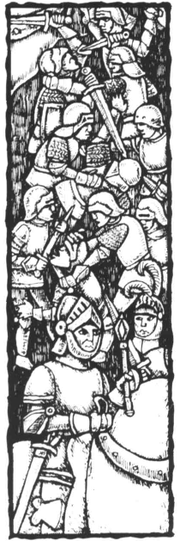
Marriage Contracts
Marriage Contracts are binding agreements between players, and should be written out on the blank Marriage Contracts provided.
Marriages can be - and usually are - subject to a Marriage Contract. The nature of these contracts is extremely varied. They can cover agreements about trade, safe passage of trade, non-aggression, exchange of land, exchange of goods, money, etc. Anything is permitted in a Marriage Contract that does not contravene the game rules. These contracts cannot be broken under any circumstances. For as long as the marriage exists (ie, whilst both partners remain alive), the conditions of the Marriage Contract apply.
There may be circumstances in which a player finds it impossible to meet one of the conditions of a Marriage Contract that is entered into in good faith. Obviously, if Player A has agreed to send a clothing trade item to Player B each turn as part of a marriage treaty, and subsequently loses the supply centre that produces that item, then that player is going to find it very difficult to meet that obligation. Similarly, if Player A agrees a mutual non-aggression clause with Player B, and a mutual support in time of war clause with Player C, that player is going to be in grave difficulty if Player B declares war on C.
There is no penalty if a player becomes incapable of meeting an obligation in a Marriage Contract through no fault of his or her own. However, players may never place themselves deliberately in such a situation. In the examples above, Player A may not sell the clothing trade good to another player as long as it is contracted to another player. With a bit of experience, players will learn to include clauses in the contract which allow for the possibility of a later problem. Player A could state that the clothing trade item will be sent to Player B for as long as the supply centre is in Player A's hands (which would have the beneficial effect of ensuring that B assisted him in holding onto it); likewise, Player A could exclude support for any war between B and C when signing the mutual support treaty with C.
Players should also make every effort to fulfil the Marriage Contract. Stalling or finding excuses not to do something that is part of a Marriage Contract, even if this places the player at a disadvantage, is against the spirit of the game.
The details of the Marriage Contract should be written on the blank Contracts provided. The terms must be precise. If there is a fixed term for any clause, this must be clearly stated. Likewise, if there is a starting date for a part of the agreement (such as a regular exchange of Trade Items), this should be recorded as part of the Contract. (See Example 5)
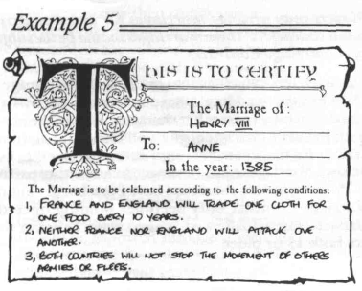
The Effects of Characteristics
A bride's Guile score should be added to her husband's
Strength score.
Brides with positive or negative Charisma scores bring
a cash bonus/penalty to their husband's player of 30
Crowns x the Charisma score.
A character marrying a King or Queen or a character
who later becomes King or Queen brings a 100 Crowns
bonus to his or her Dynasty.
Brides confer additional military strength bonuses/penalties to their husbands in accordance to their Guile rating (see Birth - Characteristics (6)). A bride with a + 2 Guile score who married a character with a 0 (normal) Strength rating, would make him effectively + 2 as long as the Marriage lasted (see Combat (19)). However, a bride can never modify a husband's score above +2 or below -2.
Brides with a positive Charisma score bring a cash benefit to their husbands, and those with a minus rating bring a cash penalty. At the time of the wedding, a bride with a +1 score confers a 30 Crown benefit on the player of the male character, and a bride with + 2 Charisma confers a 60 Crown benefit. This can be thought of as a donation from the happy people of the player's country. If the bride has a negative score, thentheplayer of themale character must pay 30 Crowns to the Treasury for a -1 Charisma bride, and 60 Crowns for a -2 Charisma bride. This represents the extra money that has to be spent for anyone in the country to recognise that this was such a good idea...
If a bride marries a King or a Prince who later becomes a King, the player from whose Dynasty she came receives 100 Crowns from the Treasury, either at the time of the marriage or when the male character succeeds to the throne. The same applies to a male child who marries a Queen or a Princess who becomes a Queen in her own right (ie, succeeds to her Dynastic throne). The people of the player's country are showing their delight at such a fortunate match.
Marriage and the Succession
Players must guard against losing control of their Dynasty's Crown through another player's character inheriting the Throne.
Each player must try to protect the interests of his or her Dynasty. If a player is short of sons (or his sons are somewhat sickly!), hemust look to his daughters. If they are to marry, the player can try to ensure that the Marriage Contract includes a clause that says that the prince relinquishes any claim to his own Dynastic throne, and that any children of the marriage will be brought up as part of the bride's Dynasty.
If the two players agree that the husband will join the female character's Dynasty, the husband's character sheet should be given to the player of the female character. He can fight as a prince of her country and any children of the marriage - whether they carry his Dynastic name or his wife's - will be treated just as if they were the children of a male character. This could lead to situations where a Prince did battle against his father - history has many examples of this!
Should a married female character ascend the throne, her husband will become Consort, and - if not already the case - the player controlling the Queen's original Dynasty will take control of the Queen, her Consort, and any children of the marriage. The only benefit to the male character's original player is the 100 Crown payment for a marriage to a monarch (see above).
If a player finds no other player will provide him with amarriage under these conditions, he may end up without a Kingdom, and another player may end up with characters ruling two Kingdoms (see Succession -Controlling Two Countries (9)).

Marriages and Children
The children of a marriage are always brought up by the male character's Dynasty, except where the Marriage Contract says otherwise, or in cases where the wife becomes Queen of her original country (see Succession (9)).
(9). Succession
When a King dies, the next-in-line comes to the Throne.
In the majority of cases, the act of succession is quite straightforward. The King dies and his eldest son becomes King.
But on the occasions where there is no obvious candidate for the throne, it is necessary to search wider for the successor (making use of the parents' names and Year of Birth information on the Character Sheets).
The order of Succession is as follows:
The eldest son then down through his family, boys and then girls;
The second son and down through his family - first the boys then the girls;
The third son, and so on;
The eldest daughter and down through the sons in her family, then the girls;
The second daughter, and so on.
(See Example 6)
If no successor can be traced, the King is assumed to have a relative, who can then be created and played by that Dynasty's player. This relative is 5 years younger than the deceased King (or 20 years old - whichever is the older), is married to a wife 5 years younger than himself, and has a child for every five years of their marriage, starting from when the male character was 20. The player should create Character Sheets for the new royal family.
When a Prince ascends the throne, the controlling player should at once exchange the King piece for the Prince's piece on the board. The King piece can either be placed in the capital, in the province where the Prince was before the Succession, or in the province where the previous
King was. The change in the piece representing the character should be recorded on the character sheet (by substituting a 'K' for the prince's number).
Female Succession
A female character who becomes Queen is always controlled by that country's player; if she is married, and controlled by another player when she becomes Queen, she is returned to her original player, alongwith her husband - the Consort - and any children of the marriage.
If the new Queen is married to a King, or a character who becomes King, a Dynastic Union takesplace, and the player of the male character takes control of both countries.
When a Queen ascends the throne, the rules of Succession become slightly more complicated. The King piece is removed from the board, since the Queen may never leave her capital. Her Charisma rating is still used for Rebellions (see Events (15)), and she performs all other functions of a King, though she may not be moved from the capital, or lead armies.
In addition, if the Queen is married, and controlled by aNother player at the time she inherits the throne, she is returned to her original Dynasty at once. She brings any unmarried children from the marriage, and her husband, who is then Prince Consort. His Prince piece is swapped for one in the Queen's country's colour, and this is placed in the Queen's capital. To all intents and purposes, all these characters are now controlled as normal by the Queen's player.
If a married Queen dies, her Consort is returned to his original Dynasty, in the same way as most female characters return to their original Dynasty when their husbands die (see Marriage (8)). The children of the marriage stay with the late Queen's player.
The exception to all this is when the Queen is married toaKing.ortoacharacterwho becomes King of another country. In this case, control of the King, Queen, and all children of the marriage remains or reverts to the male character's player. In such a case, too, a Dynastic Union would have taken place, and the male character's plaver

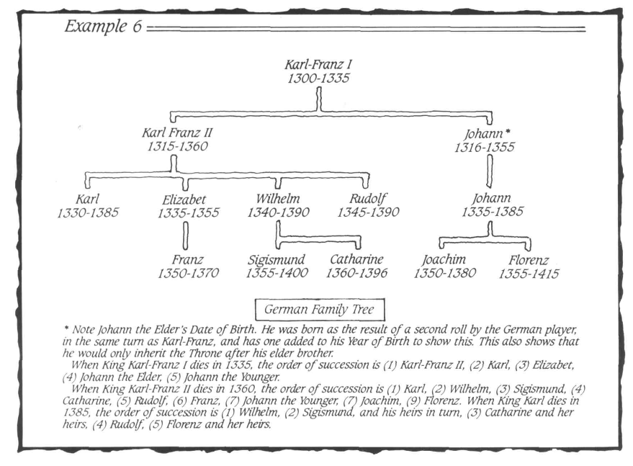
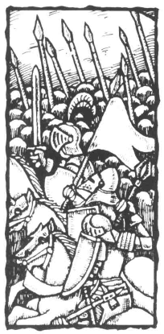

would be in control of two countries (see below). To avoid this, a player may pass over a female character as a Queen, in a Disputed Succession (see below).

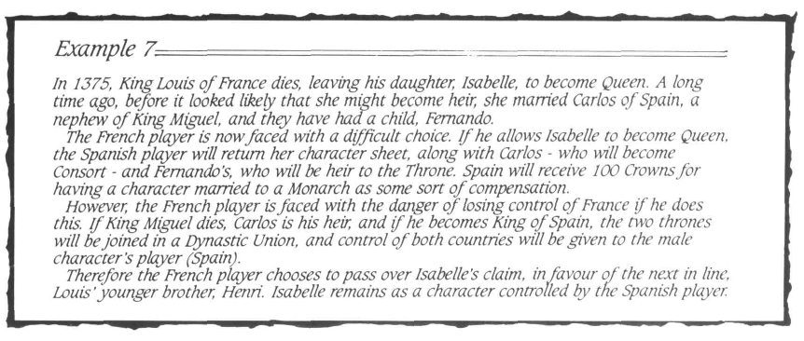
Disputed Succession
Players may choose to pass the rightful heir to the throne in only two circumstances; if the character is a prisoner, or if the character is a female, and married to a foreign character (and controlled by another player as a result). There are penalties for doing so.
A player can pass over a character who is the legitimate heir to the throne in certain rare circumstances. These are when:
a) the heir is a prisoner in another country, or
b) the heir is a female character controlled by another player as a result of a Marriage.
There are likely to be penalties to be paid in the form of unrest at home or antagonism from abroad, but a player might feel these were preferable to allowing the succession to follow a female line, or to allowing a King to come to the throne when he is a captive.
If the heir is a prisoner, and the player does not pass over that character, the player will be running an increased risk of Rebellion through the King being away from the Capital (see Events (15)).
Players are more likely to want to pass over a female character for the Succession, when she is married to a Foreign King, or a Foreign Prince who might come to inherit his own Throne.
Normally, a female character who comes to the Throne would be returned to her original Dynasty, bringing with her her Consort and any children of the marriage. By compensation, all the other player receives is the 100 Crowns for having a character married to a Monarch (see above and Marriage and the Succession (8)). However, the complication arises when the Consort is a King, or becomes King while still married to the female character. In this case, a Dynastic Union has taken place, and the player with the male character will have gained control of both countries (see Controlling Two Countries, below).
A player with a female character who is likely to ascend the throne (ie, is the heir presumptive) can attempt to insist on a clause in any potential Marriage Contract whereby the husband renounces any claim to the throne of his home country. In this way, the husband will come to live with the female character, and will become Consort if she becomes Queen; the children of the marriage will also remain within the mother's Dynasty. (See Example 7)
These rules only apply for matters of Succession when a reigning Monarch dies. Monarchs may not abdicate, nor be deposed.
Penalties for Passing Over A Legitimate Heir
If a player passes over a legitimate heir, allothermale characters in his or her Dynasty receive a -1 Penalty to Strength. Male characters in the Dynasty controlling the passed-over character have a +1 bonus to Strength when in combat with the 'usurper' Dynasty.
If a player passes over an heir to the Throne because she is a female character married into another Dynasty, all male characters in the player's Dynasty fight with a -1 penalty to their Strength score (which can reduce a character's Strength below -2; see Birth - Effects of Characteristics (6)) for as long as the legitimate heir to the throne, or her heirs, is still alive. This represents the resistance of the country's population to the wrongful succession.
Additionally, the Dynasty controlling the rightful heir has a +1 bonus to Strength for all its characters whenever they are fighting the 'usurper' Dynasty. This penalty too is retained by the player's Dynasty for as long as the legitimate heir to the throne, or her heirs, is still alive.
A player controlling a passed-over character must agree to renounce the claim of a passed-over character, or her heirs, as part of a Marriage Contract with the 'usurper' Dynasty. Alternatively, it is possible for there to be a rival claimant to the throne for the rest of the game - making the player's task permanently difficult. It would be as well to arrange for a marriage contract by which the rival renounces the claim as soon as possible (this dropping of the claim would last even after the end of the Marriage Contract).
If a player chooses to pass over a rightful male heir who is being held prisoner by another player, all his or her male characters fight with the -1 Strength penalty, as outlined above. Additionally, the Monarch receives a penalty to his or her Charisma score, representing the factions that will cause trouble once they have been given a 'cause'. The player should roll a die. A result of 1-3 means the new monarch's Charisma is reduced by -1, and a result of 4-6 reduces it by -2 (this may reduce the character's Charisma score to -3 or -4!). This penalty cannot be inherited by any of the new monarch's heirs, but can reduce the monarch's Charisma below -2. (See Example 8)
Controlling Two Countries
If a Dynastic Union takes place, because the Queen of one country ismarried to the King of another, themale character's player will control both countries.
For the player controlling two countries, there are obvious advantages, and some disadvantages. The player controlling the 'annexed' country has complete control over it (and can therefore tax, raise trade items, raise troops, etc). Existing Army and Fleet counters on the map remain in play, controlled now by the new player. The Player Order marker for the controlled country should

be placed to one side; in the Movement Phase the Army and Fleet counters will be moved at the same time as those of the controlling country.
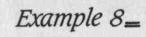
Continuing example 7 above, having made the decision to pass over a rightful heir, the French player now has a -1 modifier on all male characters' Strength for as long as isabette or any of her heirs are still alive, and have not renounced their claim. The Spanish player will have a +1 bonus for his male
character's Strength for the same period, whenever he is in combat with the French. The French player decides he must obtain a Marriage Contract with Spain as soon as possible, in which Isabelle renounces her claim.
However, the unrest a foreign ruler causes will have a negative effect. Apply a -2 modifier on the monarch's Charisma when rolling for Rebellion in any Home Province in the annexed country (this can reduce a character's Charisma below -2 - see Events (15)). This continues for as long as the country is ruled by a' foreign' monarch (ie, a character who is controlled by a different player).
Also, the foreign monarch may raise only 1 Army per controlled Province, and not two.
Since Rebellion can be costly, and might even spread into the player's own country, and since the annexed country might be more difficult to defend, a player in this position might prefer to abandon any rights to it, and allow a new Monarch to be established by the 'landless' player. The player must return all Home Provinces (but not captured ones, necessarily), unless a Marriage Contract can be arranged which ceded certain Provinces to his or her control.
If a player lost control of country because his or her Dynasty died out, the player should be allowed to establish a new Dynasty, following the procedure followed when no heir can be found (see above).
On the other hand, if a player remains landless for any length of time, he or she is in real difficulties, though the player might have hopes of regaining the throne through normal rules of Succession. In the meantime, that player can only continue in the game as a Baronial Dynasty. At the time the player loses control of his or her country, he or she will still have control of the Dynasty's money, and any Prince counters on the map. He or she would still be part of the Dynastic Sequence, but could only Raise Taxes or Trade Items with the express permission of another player, who would forfeit the income from his own Tax or Trade revenues. The aim of such a player would have to be to place one of his children in an advantageous marriage, which inherited a throne from another player through the normal rules of succession. The odds on this happening twice in a game are very slight, however, and the player could be effectively out of the game. (See Example 9)
Procedure In The Case of a Minor Ascending The Throne
If a character who is less than 15 years old inherits the throne, the player should establish a Regent, who will be regarded as 'King'as far as the rules are concerned.
If the legitimate heir to the Throne is less than 15, a Regency is established. The player can bring in any other character to act as Regent (if he or she is of age). If none are available, a baron or cousin of the late King is created. He is 5 years younger than the late King (or 30 years old, whichever is older), and characteristic die rolls are made for him.
If an existing character is made Regent, he or she merely assumes the role of King and all its vested powers until the true King reaches 15. At that time, the character reverts to his normal role. If a character was created to be made Regent, he is simply retired from the game at this stage. He has no wife, does not marry and produces no children as far as the game is concerned.
(10). End of Dynastic Sequence
Players should inform each other of all Births, Deaths and Marriages which took place during the Dynastic Phase.
At the end of the Dynastic Sequence, players must Announce what has happened to their Royal House. In other words, they must give a verbal report on Births, Deaths and Marriages, so that players who have been otherwise occupied with their own affairs know what has been happening. It is at this stage that any the brides of dead Princes (or the husbands of deceased female characters) are returned to their original Dynasty.
Players must include the information about new characters' Characteristic scores. These are never kept secret.
(11). The Interphase - Taxation
Players tax the Provinces they control; they may tax them at either 5 Crowns or 7 Crowns per province.
During the Taxation phase each player receives 5 Crowns for each province he controls (see Controlling Provinces (17)), that is not affected by Famine or Rebellion (see Events (15)). Players may - if they wish - increase their tax revenue by taking 7 Crowns per province; if they choose this option, they must apply a-2 modifier when determining if a Rebellion breaks out during the Event section of the Movement Phase. Players must tax all their Provinces at either the 5 Crown or the 7 Crown rate - they may not tax provinces at different rates.
Players should record their Taxation levels on scrap paper and reveal their decisions simultaneously.
(12). The Interphase -PlacingResources
Players should place one Resource Item on each of the relevant Resource Areas on theboard. No Resource Item should be placed in an area affected by Famine.

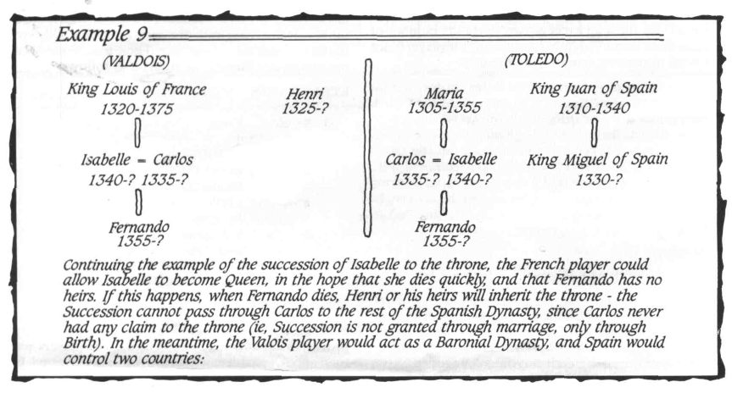

Certain provinces are considered to be Resource Areas. They are marked on the board with the appropriate symbol, signifying that they are major producers or importers of basic commodities - food, metal or cloth goods etc - or of finished goods - semi-luxury or luxury items.
At the
beginning of the Maintain/Raise troops pan of the Interphase in the First 5-year Turn (1300), no Army counters exist on the board -therefore all must be Raised. Players should Raise the troops they require, spending money to do so, and place these troops in front of them. If a playerfinds other players have placed him or her at a disadvantage by the numbers they have recruited, he or she may raise additional Army/Fleet counters, and this should continue until all players are satisfied - or broke! At this point, the Army/Fleet counters can be placed on the board. In this first turn, instead of them all being placed in the capital, players should place Army/Fleet counters they raise anywhere in their Home Provinces, placing them one at a time, and taking it in turn round the table.
During the Placing Resources part of the Interphase, players shouldplace the appropriate Resource Counters on every Resource Area which is not affected by Famine (see Events (15)). Therefore, a maximum total of nine 'basic', two semi-luxury and one luxury Trade Item counters will be placed on the board each Interphase.
Resource Item counters are placed on the board during the Interphase even if the Resource Area still contains previously-placed counters. Only Famine - signified by a Famine marker - automatically stops the production of Resource Items in that province. Players may, however, choose to destroy Resource Items in any Province they control during any Movement Phase, prior to the resolution of any Combat.
(13). The Interphase - Maintaining and Raising Armies and Fleets
Each player must pay 2 crowns for each Army counter and Fleet they have on the map. The player may raise new Armies or Fleets by paying 5 crowns.
In the Maintaining Forces part of the Interphase, each player must pay 2 Crowns to maintain each of the Armies and Fleets he or she has on the map. This money is paid into the Treasury. Any Army Counters or fleets that are not maintained are removed from the map. When a player pays maintainence for some, but not all, of their Army counters or fleets, the player may decide which are to be removed.
Each player may increase the size of his forces and replace losses by paying 5 Crowns for each additional Army and Fleet he wishes to place on the map. Each country has a maximum of 20 Army and 4 Fleet counters, this being the maximum force any player can deploy on the board (unless, under the rules of Succession, a player comes to control more than one Kingdom).
New armies are placed in the Capital and Fleets in any coastal Home Province (ie, a province of his original country that he still controls, ignoring any provinces gained at the expense of other countries). Additionally, a player may never bring additional Armies onto the map if that would increase the number of armies he has deployed to a figure greater than two times the number of Home Provinces he currently controls and which are not in Rebellion. However, if the number of Armies already on the map exceeds two times the number of controlled Home Provinces at any time, the player is not forced to remove Armies from the map.
Troops raised as replacement for losses are drawn from the stock of Army Counters to the side of the board. Players may not raise troops from the Army counters on the Year Track. Instead, at the beginning of the Interphase, players may recover Army counters from the space representing the current year on the Year Track, and place them at the sideof the board. This off-map 'pool' of Army counters represents the full potential of the country to raise troops. For a full description of how the Turn Record Chart works (see Game Equipment (1)). (See Note 6)
(14). Movement Phase - Player Order
In the Movement Phase, the players move in a strict sequence known as the Player Order. Each player, in turn, moves and resolves combat for their Army Counters, Royal Pieces, Fleets and Resource Markers. The Player Order is decided using the colour-coded Player Order markers, using the following procedure:
1. The 5 Player Order markers should be placed in a cup or similar container, and a player should draw one, and show it to the other players. The country indicated by the marker will play through the Movement Phase first.
2. The player of the country revealed by this draw then rolls one dice, and compares the result to the Events Table (see Events (15)). The Event occurs immediately.
3. The first player takes his or her turn to move and resolve any attacks (see Movement (16) and Combat (19)).
4. The first player then draws another Player Order Marker from the container, to establish the second player (the drawn Markers should be placed to one side until they have all been drawn). The second player then takes his or her turn to move and resolve combat, and to draw the next Player Order marker. This continues until all players have taken a turn to move and resolve combat.
5. The Player Order markers are then returned to the container, and steps 1-4 should be followed through a second time, with the first player making the roll for Events, and each player taking a turn to move and resolve any combats.
Note that their is only one event per Movement Phase, not one event per player.
(15). The Movement Phase - Events
The first player rolls a dice and compares the result with
the Events Table. The Event takes place immediately.
Plague destroys armies, and characters away from the
capital make Survival Rolls at -1.
Army counters must be moved from areas affected by
Famine; no Trade Items will be raised in a Famine area
next turn; No counters can be moved into or through
the area.
Rebellion areas may not be taxed; Trade Items are not
raised in Rebellion areas; Trade Items may not be moved
through Rebellion areas without accompanying A rmy
counters.
Ships at sea in an area affected by Storms are lost on
a die roll of 1-2.
During each Movement Phase, before any Movement is made, the first player (determined at the beginning of the Movement Phase) rolls one die to determine if an event has taken place that 5-year Turn. There is only one Event per Movement Phase. The result is as follows:
EVENT TABLE
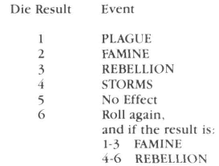
Effects of Events
PLAGUE: A second die rollis made to establish how many provinces are affected by the Plague. The players will then need to establish which provinces are affected, by rolling on the Random Provinces table (see below).

All Army counters in a Province affected by Plague must be removed and placed on the Turn Record Chart (seeGame Equipment (1)). A King or Prince in a Province
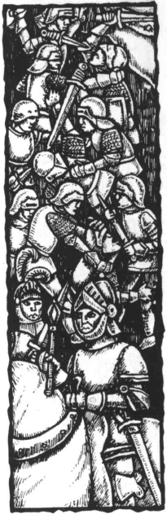
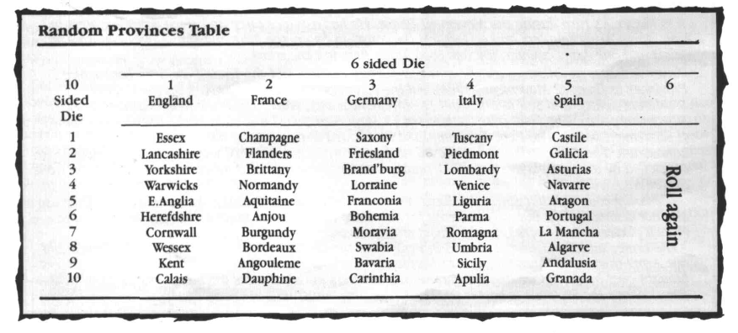
_3ffectediw_Ptxojj*" must mqVe a Survival Hr»ll fc*»*» rif>afh
(7)), subtracting one from the die roll. Characters who fail this roll are removed from the game in the same way as if they had died in the Dynastic Phase. Characters (not Armies) resident in their capital are never affected by Plague.
FAMINE: A second roll is made to establish how many provinces are affected by Famine. The players will then need to establish which provinces are affected, by rolling on the Random Provinces table (see below). Place a Famine marker in every Province affected by Famine.
All Army units in a Province affected by Famine must evacuate the Province during their next Movement turn. No Army counters may be moved through a Province affected by Famine, and the Province produces no Taxes or Resource Items during the next Interphase. Famine markers are removed after Taxes have been raised and Resource Items placed.
REBELLION: Each player rolls a die once for each province he owns, and modifies the result by considering any of the following circumstances which apply. No die roll is made for a province containing 4 or more Army units (a King or Prince piece counting as one unit).
The following circumstances modify the die roll: The Monarch's Charisma rating is applied to all die rolls;
If the Monarch is away from his capital, a -1 modifier is applied to all die rolls;
If there has been additional Taxation (see The Interphase - Taxation (11)), a -2 modifier is applied to all die rolls;
If a Royal Male is present in the province (represented by the Prince's numbered pawn), his Charisma rating is also applied to the die roll for that Province;
If an adjacent province* is in Revolt from a previous round, a -1 modifier is applied. The Monarch's charisma can be affected by a Disputed Succession (see Succession (9)).
A roll of 1 or less (after adjustment) means that a Rebellion has occurred in that Province. Place a Rebellion marker in the Province
A rebellion is automatically put down, and the marker removed, if 4 Army counters are moved into the Province and remain there at the end of a Movement turn (the marker is removed during the Combat section of the Movement Phase). King or Prince pieces count as 1 Army counter. Rebellion markers can also be removed by
* which must be in the same Kingdom (ie, controlled by the same player) - Calais counts as adjacent to Kent
payment of 15 Crowns per marker during the next Interphase, after Taxes have been raised and Resource Items placed. A Province marked with a Rebellion marker
Interphase.
Army counters, and Trade Items accompanied by Army counters, may move normally though a Province affected by Rebellion. Unaccompanied Resource Items may not be moved into or out of a Province affected by Rebellion.
STORMS: For each Fleet at sea (ie, not placed on the coast), roll one die. On a roll of 1 or 2, the Fleet and all its contents are lost. The Fleet is returned to the side of the board. Any Army counters lost are placed on the Year Track as if they had been lost in Combat (see (19)). Resource Items are returned to the side of the board. Any Royal characters aboard the Fleet when it was lost die.
Random Provinces Table
To establish the location of a Famine or Plague Event, roll a six-sided die, and then the ten-sided die. If the same Province is rolled twice, ignore the second roll and roll again, (see table below)
(16). The Movement Phase - Movement
Armies may move up to 3 Provinces each Movement
Turn.
Fleets may move up to 3 Sea Areas, and may carry up
to 6 Army counters or Royal pieces, and any number
of Resource Items.
Resource Items may move up to 4 Provinces each
Movement Turn.
Armies, Kings and Princes
Army counters, and Kings and Princes pieces may be moved up to 3 Provinces during the Movement phase by the owning player, provided that:
(a) the player controls those provinces; or
(b) the provinces are friendly to the
moving player (ie, the owning
player either grants permission
verbally, or access is permitted
through the terms of a Marriage
Contract);
As soon as Movement takes the piece/counters into an unfriendly country, those pieces must stop Movement at once, no matter how many Provinces they have already moved.
Embarkation and Disembarkation costs one Movement point out of the possible 3.
If any country controls both Kent and Calais, Army counters and Kings and Princes pieces may be moved

•13

across the Channel at a cost of 1 Movement point if no unfriendly Fleets are at sea in that Sea Area. No Fleet is needed to accomplish this move.
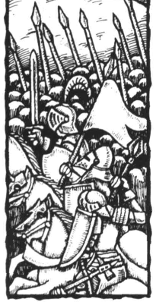
It is Player A's turn during the Movement Phase. He has a Prince piece and three Army counters in Kent, three Army counters and a Fleet (on the coast) in Essex, the King and three Army counters in Calais and one Army counter and one Food Trade Item in Lancashire.
Player A moves as follows. First, he moves the Army counter and the Trade Item from Lancashire 2 Provinces to Essex (2 Movement points). All the counters now in Essex embark on the Fleet (1 Movement point), and sail to Fnesland (1 Movement point), where the Trade Item is disembarked (1 Movement point). The Fleet puts back to sea (1 Movement point) and sails to the coast of Normandy (1 Movement point). The Fleet has completed its allowed Movement, as has the Army from Lancashire. The Trade Item may be moved no further by Player A, since it is now in a Province controlled by another player, but the German player may move it on if his or her turn follows on from Player A's.
The Army counters that started in Essex have used only one Movement point (embarking). They use another disembarking, but may move no further since they are now in an unfriendly Province (the French player is being very negative about this invasion).
The Prince and the 3 Army counters in Kent cross the Channel (1 Movement point). The Prince and one Army then move through Calais to Normandy (2 Movement Points). The King, the Army counters brought over by the Prince and the three Army counters in Calais move to Champagne (1 Movement Point). Since the Province is hostile (!), the King's army must halt in Champagne.
Fleets
Fleets may move 3 sea areas. Putting to sea costs one Movement Point (ie, moving from the coast into the sea area is considered as being one move). Once a Fleet has put to sea, it can be placed in that sea area (in which case it is 'at sea'), or anywhere on the coast of that area (in which case it is 'in port'. This means that a Fleet could leave Cornwall and place itself in Herefordshire, Wessex, Normandy, Brittany, Aquitaine or Bordeaux for one Movement Point.
A Fleet can carry a maximum of 6 Army counters and King or Prince pieces combined, and an unlimited number of resources.
Players may combine land and sea movement, so long as the counters/pieces involved have sufficient Movement points. Royal pieces, Army counters and Resource Items do not count Sea Areas they move through when aboard a Fleet. Therefore, an Army counter or a Resource Item can be moved into a Province, embarked on a Fleet, moved 3 Sea Areas by the Fleet, and debarked at the other end.
If a Fleet at sea encounters Fleets from another player's country, and that opposing force is greater in size than theirs, that Fleet's movement must cease for that turn (Fleets in port have no effect on this, they must be at sea). No battle ensues. Movement may continue in the following turn. Fleets from two or more players may not be combined to prevent the movement of another player's Fleet.
Fleets may seek refuge in the country of any player. Permission may be given at the time, or as a result of a Marriage Contract. If permission is given, any Army counters on board remain there, and have no effect on the control of the Province in which they have docked. They are affected by Plague, should that break out in the Province, and if there is Famine they must put to sea at the earliest opportunity.
If a Fleet has no permission to dock, and has no Army counters aboard with which to launch an invasion, it may not dock.
Resource Items
A player may move any Resource unit up to 4 provinces during the Movement Phase provided that he or she:
(a) controls those provinces;
(b) has another player's permission to move freely through his or her country as a result of a Marriage Contract (verbal permission is not enough);
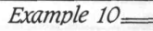
Failing the above, a Resource Item must cease movement once it enters another country, even though that country may be prepared in its turn to continue its movement. If a Resource Item is transferred across a frontier in this way, the receiving player may move the Resource Item up to another four Provinces, subject to the same restrictions, during his or her turn. Also a Resource Item may be placed on the coast of a Province by one player, who may give permission to another player to embark and ship the resources in their turn.
A player can capture another player's Resource Items by any of the following methods:
(a) by capturing the province in which they are located;
(b) by confiscating any that are in transit through the player's Country;
(c) by capturing a capital in which they are being held.
If a Resource Item is accompanied by an Army counter, that army must be defeated in battle before the Resource Item can be captured (see Combat (19)). (See Example 10)
(17). Controlling Provinces
Control of Provinces is signified by Control markers. A player may place a Control marker on a Province solely occupied by bis or her Army counters at the end of a Movement Phase. A player can be said to be controlling a Province if:
(a) it is one of that player's Home Provinces (ie, one he or she controlled at the beginning of the game), and is unoccupied by any other player's control markers;
(b) it is other than a Home Province, and is occupied by the control markers of that player.
Control of a Province affects Taxation, the ownership of Trade Items when they are first placed upon the board, Rebellion and Movement.
The Provinces of Denmark, Wales and Poland, though marked on the map, may never be controlled by any player. Players may never move pieces or counters into or through these Provinces.
When a player first gains control of a Province, it should be marked with one of that player's control markers. This is not necessary when the Province is one of that player's Home Provinces.
Control of a Province is gained when the following conditions occur. If a player occupies a Province that

was previously controlled by another player with one or more Army counters at the end of a Movement phase, and there are no Army counters belonging to any other players in the Province, that player is entitled to (but does not have to) place a control marker in that Province, unless prohibited from doing so by a Marriage Contract.
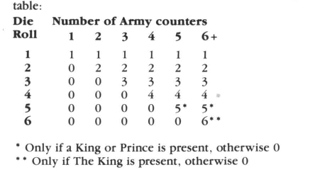
Example 11=
France and Italy are at war. France invades Lombardy, led by the King (Strength +1) and the Crown Prince (Strength -1). Italy's defence is led by 2 Princes (Strength +1 and -1). France must count the King's bonus, but has a choice as to whether the Prince is counted -obviously he chooses not to count the Crown Prince. So France is entitled to one pre-battle roll. Italy must count both Princes, so the penalty and the bonus cancel out. The end result is that France will make one pre-battle roll. If the weaker-Italian Prince had not been present, both Italy and France would have been entitled to pre-battle rolls, so they would have cancelled each other out.
(18). Capitals
A player's capital is also a Castle. The Capital counts as 10 Strength points in defence.
A country's capital is considered to be the permanent base for those of his or her characters who are not represented by royal pieces. The capital is also a castle, and gives the owning player an advantage in combat.
The capital is considered to have a Strength equivalent to 10 Army counters. This represents both the defences of the castle and a garrison of troops. Additional Army counters can be placed in the Castle which will add to its Strength (however, once an attack is under way, additional troops cannot be brought into the Castle; they are considered to be camped outside, andean be attacked separately - see Combat (19)).
A Castle's Strength can be gradually depleted by Combat during the Movement rounds of a single turn, but - if still uncaptured - it returns to full Strength (ie, 10) at the beginning of the next Interphase.
The Province in which a capital is situated cannot be captured unless the 'castle' is taken.
If the capital is taken, the defeated player may nominate any other controlled Home Province to be his or her capital, and should place his or her Capital Marker in that Province. This new Capital would not be considered to be a castle. Once a castle is destroyed, it may not be rebuilt. The Capital Marker is removed as soon as a player recaptures his or her original Capital.
If the 'new' Capital is captured, the Marker should be replaced in another controlled Home Province. If a time ever comes when a player has no controlled Home Province in which to locate a Capital, all other Provinces they control are returned to their original owners, and the player must continue as a Baronial Dynasty (see Succession - Controlling Two Countries (9)).
The ruler of a country which loses or has lost its capital shouldhavehisorherCharismascorereducedby 1 until the capital is retaken. This adjustment may not take the minimum/maximum Charisma score outside of the normal +2 - -2 range.
All characters in a Dynasty other than those represented on the map by King/Prince pieces are assumed to be in the capital at all times. If the capital falls as the result of combat, they automatically escape to the new Capital.
(19). Combat
When two or more players have Army counters in a Province, combat may take place. Players make a die roll, and the opposing player loses Army counters, which are placed on the Turn Record Chart.
Combat can take place at the end of each player's movement phase, whenever Army counters of two or more players are present in a Province. Either player may declare an attack, in which case he or she is deemed the Attacker, and the other player the Defender. The moving player decides if they wish to attack first; if they decline the non-moving player may elect to attack.
All the Royal pieces and Army counters in the Province take part in the battle. Combat is conducted as follows:
(a) Before the battle takes place, there may be one or more pre-battle rolls to reflect the advantages gained by a superior Royal leader. See the sub-section Effects of the Presence of Royal Pieces below.
(b) Combat between the surviving forces of each player is then resolved. Each player should make a single die roll, and remove casualties from the opposing front-line Force, as explained below. All these die rolls are considered to be simultaneous, even though the rolls will be made one after the other in practice.
The effect of the die roll is summarised on the following
Cross-reference the number of Army counters in the army (a King or Prince counts as one Army counter) with the die roll; the result is the number of casualties which must be removed by the other player. Casualties removed in this way are placed on the Turn Record Chart (see Game Equipment (1)).
Battles continue - with Rounds of both players making simultaneous die rolls - until one side or the other is eliminated, surrenders, or flees the field. The victors remain in the Province in which the battle took place; fleeing losers may be moved by their owning player to any adjoining Province (where they could, theoretically, be attacked again by any unfriendly Army counters there).
It will be noted that the optimum size for any force is four Army counters (although the presence of Royal pieces may change players' minds on this!). If a smaller number of Army counters is deployed in a force, the greater the chance that that force will have no effect.
Effects of the Presence of Royal Pieces
A King or Prince with a positive or negative Strength score has an effect on the outcome of a battle, even before the battle itself takes place. If a Royal Piece with a +1 Strength score is part of an army in a Province, he gets one free die roll before the battle starts with which he can inflict casualties. On aresultof 1-4 (if there are at least four Army counters present), 1-4 casualties are removed from the opposing force. If the roll is 5 or 6, or more than the number of Army counters in the force, no casualties are inflicted.
If the Royal character has a + 2 Strength score, he gets two pre-battle rolls. If the Royal character has a minus rating, the opponent gets the pre-battle rolls. The opposing player cannot retaliate to these free rolls.
For the purposes of these pre-battle rolls, the Royal piece does not count as an extra 'man', and does not alter the maximum casualties which can be inflicted. These two bonuses only count for the main battle.
Although no single Royal Piece can accumulate more than + 2 or -2 on his Strength score, if there is more than one Royal piece on the same side, they can co-operate to give that side more than 2 free rolls in this pre-battle phase (this also applies to free rolls gained by the opponent's minus ratings). If a King is present on either side, his Strength bonus/penalty must be counted. Any Princes present may be counted at the owning players discretion. However, when there are only Princes present on one side, all their bonuses/penalties must be counted.
Only one side makes the pre-battle roll. Where both sides are entitled to pre-battle rolls, these should cancel out.
(See Example 11)

In the battle proper, if a Royal Prince is present, he counts as one Army counter for die roll purposes, and the maximum number of casualties the Force can inflict increases from 4 to 5 (though once the Force drops below 5, this advantage is lost).
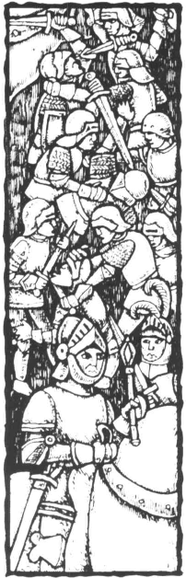
If a King is present in a Force, he counts as one Army counter, and the maximum casualties the Force can inflict increases to 6.
If a Royal piece is present at a battle, and that character's army suffers casualties which wipe out its total strength (including the Royal piece), the Royal character must suffer the consequences; he will be captured or killed. The player should make a Survival Roll for the character, subtracting one from the die roll. If the result is that he would have died, the character is removed from the game in the usual way (see Death (7)). If he survives this roll, the character is captured (see below). Captured characters may not be killed.
Fleeing From Battle
A Royal character can escape from a battle at any time, even if he is the only surviving 'unit' in an army after casualties are removed. A Royal character can be retreated to any neighbouring Province in which there are only Army counters from his own country, or none at all.
If a King or Prince wishes to make good his escape before Combat starts, he is not permitted to make use of his Strength bonus. If his Strength rating is taken into consideration in the pre-battle rolls, the Royal Charater must remain for at least one round of combat.
Retreating
At the start of a Round of combat, either player may choose to retreat with his or her surviving Army counters. The opposing player is allowed one free attack. Retreating forces may move to any neighbouring Provinces, regardless of the presenceof other Army counters. They may not attack Army counters in that Province, but may be attacked.
Surrender
At the end of a Round of combat, either player may offer surrender to the other side. Terms may be negotiated, or the players may be unable to agree. If the latter, the battle continues. If the former, the surrendering player must comply with the surrender terms as they affect the pieces/counters in that army and the Province in which the battle is fought. Any other arrangements can be conveniently 'forgotten' once the beaten army leaves the field.
Surrendered Royal characters may not be killed (although Army counters can be), though they may be Ransomed (see below).
Captured Royal Characters
As mentioned above, Royal characters can be captured in a number of ways. If the character survives a Survival Roll (where applicable), he or she can be captured by the victorious player(s)' army, and held tor Ransom.
A captured royal character can be immediately transported to the victorious player's Capital. The object would be to Ransom the character in some way that would be beneficial for the captor. He or she could demand money, Trade Items, an advantageous Marriage Contract, anything which the other player can give within the limits of the rules. As soon as the captor is satisfied, the character can be returned to the capital of his or her own country.
No Birth rolls can be made for children for that character whilst he or she is prisoner, of course. Should the character inherit the throne whilst still a prisoner, the captive's player could pass over him or her for the succession, following the rules for Penalties as if the character were still controlled by his or her normal Dynasty.
Capitals
As stated above, Capitals count as the equivalent of 10 Army counters in combat. Only the defending player may count a Capital as part of his force; they may not be included in the Attacking force. A Capital can take casualties like normal Army counters, but these should be recorded on a piece of paper. Only when the Capital is reduced to 0 is it removed from the battle - it is considered destroyed.
Army counters inside a Capital need not take casualties until the Capital is destroyed, or may be removed as casualties to prevent the Capital's destruction. Army counters outside a capital may be attacked separately, without the Defender counting the Capital as part of his or her force. The defender must announce at the beginning of a battle whether his Army counters are inside the Capital or not; Army counters inside a Capital may not retreat.
Note that a castle which takes damage in one or more battles is assumed to be repaired during the next Interphase, and starts each Movement Phase with a Strength of 10.
To The Winner... The Spoils
Any Resource Items located with the forces of the losing player are captured when he or she is defeated in the battle, even if the loser manages to retreat.
(See Example 12) Alliances
At various times in the game, players may enter into formal (ie, bound by a Marriage Contract)and informal Alliances. All Alliances that involve joint military ventures must be made in writing. This affects combat as follows:
During the Movement Phase, whichever member of an Alliance moves before the other (as determined at the outset of the phase), may omit to move any troops which are to be involved in the joint battle plan. The last Alliance member to move then moves all the troops covered by the Alliance treaty. Combat is conducted as agreed in the treaty (ie, the players should agree who it to make the die rolls for the combined forces).
Alliances can be broken at any time (unless covered by a Marriage Contract). A player may refuse to move his or her military units at the time when the Alliance's battle plan calls for them to be moved, if circumstances have changed in such a way that the previous plan is inadvisable. There is no penalty for this, beyond the possibility of upsetting your former Alliance partner(s)...
Naval Combat
There is no naval combat in the game. If a province is captured with enemy Fleets in port, they must be moved away during the owner's first turn (they are considered to be stood-off shore together with their contents).
Some players might be tempted to introduce naval combat into the game, but this has been purposely omitted from the rules because naval combat was not a feature of the 14th Century, and - setting aside this objection - its introduction would push the game further towards wargaming.
(20). Negotiations
In order to prevent the game from getting bogged down in negotiations these should be restricted to' men on the spot'. In other words, two armies have to confront one another or a trading piece has to move to a province and then negotiate its passage. If no agreement is reached the move is wasted. Players should not indulge in 'radio' communication between heads of state prior to making a move.
Obviously, the above only applies to Negotiations conducted outside of the Dvnastic Phase

Foreign Intervention
A Monarch canenlist foreign aid under any terms agreed. If this involves military assistance (to put down rebellions, for example), the monarch's Charisma score is reduced by 1. This can have the effect of reducing a monarch's Charisma below -2.
Foreign assistance can be agreed as part of a Marriage Contract (in which case the conditions are binding), or as p*rt of a more informal arrangement. The rules for Alliances (see Combat (19)) apply for the purposes of Movement and Combat when a Monarch accepts foreign intervention, except that the player controlling the Monarch should make all moves and combat die rolls for the foreign troops, until such time as their normal owner chooses to take control of them. Inviting foreign troops onto your soil without guarantees of their behaviour is a dangerous thing to do.
(21). Cashing-In Resource Items
A player with Resource Markers at their capital may cash them in and add the money raised to their treasury.
If a player can transport Resource Items to his or her Capital, they may be 'cashed-in' at the end of any 5-year Turn, including the one in which they arrive at the capital. The basic goods are represented by metals, cloths and food resource markers. A player who has one each of these three basic Resource Items in his or her Capital can cash them in to the Treasury at the end of any 5-year Turn
for 50 Crowns. They can only be cashed in as a set (or sets) of 3.
If a player cashes in one each of the three basic Trade Items, plus one semi-luxury Trade Item, he or she receives a total of 80 Crowns from the Treasury.
If a player cashes in one each of the three basic Trade Items, plus one semi-luxury Trade Item, plus one luxury Trade Item, he or she receives a total of 120 Crowns from the Treasury.
These are the only combinations in which Trade Items can be traded in for cash. Any surplus, or any sets which the player does not wish to cash in (because he or she is hoping to add a semi-luxury or luxury Trade Item to them) may be held in the Capital until the player is able to and wishes to cash them, or until they are traded to another player. Players can hold on to Resource Items as long as they wish in the hope of improving the value of their 'set'.
(22). Ending The Game
At the end of the agreed time, the game is terminated. Players may cash in any sets of Resource items they have in their Capitals (see Cashing-In Resource Items (21)). The player with the most money is the winner.
Alternatively, at the beginning of the game players could set a monetary victory target (eg, 800 Crowns). A player with this sum or more after the 'Cashing-In' Phase of a turn is declared the winner. If more than one player has more than 800 Crowns, theplayer with the most wins.

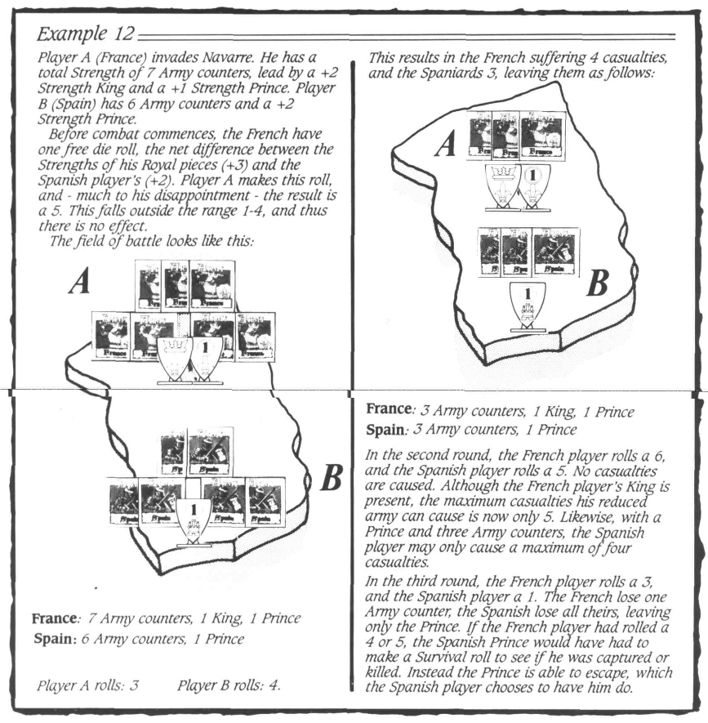
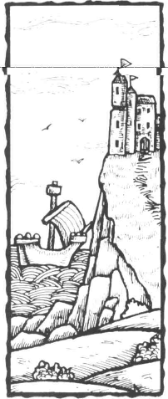

•17

(23). Special Rules For Less Than Five Players
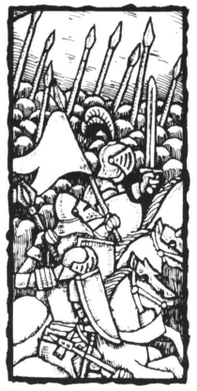
Four Players
Although obviously best suited to five players, Blood Royale can be played with a smaller number. If there are four players, one particular change is required in the rules. England becomes a non-player country, much the same as Poland, Denmark or Wales in the 5- player game. It is completely out-of-bounds to all players. Players may not move counters or pieces into or through the English provinces (not even Calais).
Experienced players might choose to alter this rule so that the 'odd- country-out' is selected at the beginning of the game. In addition players may agree that the country is not 'out-of-bounds' and that anyone may invade it (possibly making France the odd-one out, so that all the players can expand into France, if they desire). This option may unbalance the game, however; a 'neutral' Italy, for example, gives Germany the chance to swallow up Lombardy, in which case the German player has all three Basic Resources, and need never trade.
Whichever country is chosen, the players need to rebalance the Basic Resources:
If England is the non-player country, Andalusia should be considered as a Food Resource Area, instead of Cloth;
If France is the non-player country, Bavaria should be considered as a Semi-Luxury Resource Area, instead of Metals;
If Germany is the non-player country, Warwickshire should be considered to be a Metals Resource Area, instead of Food;
If Italy is the non-player country, Bavaria should be considered as a Semi-Luxury Resource Area, instead of Metals;
and if Spain is the non-player country, Lancashire should be considered to be a Semi-Luxury Resource Area, instead of Food
Combat With 'Non-Player' Countries (Optional)
In a game with four players, it is possible that players will want to attack a Province which is part of the fifth 'neutral' country (ie, one not being run by one of the players).
When using this option, at the outset of the game, Army counters should be placed in the 'neutral' country as outlined below for the 3-playergame. If a player invades the 'neutral' country, that country will defend each invaded Province only with the forces present there. 'Neutral' Army counters never move. Battles are fought following the normal Combat rules, with the 'neutral' country having rolls made for it by the player to the left of the invader. 'Neutral' countries always defend, never flee and never surrender. There are no royal pieces.
Controlling Neutral Provinces (Optional)
. For games with less than 5 players only, players may raise 1 Army counter from any controlled Province in a 'neutral' country.
Three Players
Preparation: Allow a free selection from all five countries (do not exclude England). Players may draw lots and choose the country they play, or decide their countries randomly. Because certain combinations of countries will be seen to unbalance the game, players might decide to limit the choice; each combination has its own set of challenges. Beware of combinations which allow one player to immediately gain control of Resource Areas producing the three Basic Trade Items.
The 20 Army counters of each of the 'neutral' countries are then distributed as follows: 4 in each Province
containing a Resource Area, 2 in the Capital and 1 in each other Province.
Dynastic Sequence: Create an additional 'aristocratic' family, who will be available for making marriages. At the beginning of the game there should be a five year old child (determine sex and characteristics normally), and during each turn from 1300 onwards, one player should make two birth rolls to see if additional children are born (there is no need to make Survival Rolls for the 'parents', who do not feature in the game).
Survival rules are made as the children become old enough.
When the children become old enough to be considered as marriage partners, players may make bids to secure the match. Interested players announce their wish to secure the child as a marriage partner for one of their characters, and pay the Treasury 10 Crowns as a sign of serious intent. They then write the amount of their bid on paper. When this is completed, all players reveal their offers and the highest bidsecures the match. That player pays the Treasury the amount bid, and takes the character from this additional family into his or her own Dynasty. Male children from the 'aristocratic' family always join their wife's Dynasty.
Resources: It is assumed that the 'neutral' countries make use of their own Resources. Although Resources are placed in 'neutral' countries during the Interphase, they are removed at the end of the first Movement round if not captured first.
Movement: There are three Movement rounds instead of two.
Combat: If a player moves any Army counters into a 'neutral' Province, he must attack the defending forces of that Province (if any). The die rolls for the defending army are made by the player to the left of the invader. Combat proceeds as normal .Neutral Army counters are not placed on the Year Track when killed. If, at the end of Combat, a Neutral Province has not been captured, the number of Army counters in the Province should be returned to full strength.
Controlling Neutral Provinces: Players may raise 1 Army counter from any controlled Province in a 'neutral' country.
(2 4). The Degree of Secrecy in the Game
Players may keep the details of Marriage Contracts a secret (although some details will become obvious through what follows) and they may also conceal the amount of cash they have. They may not keep the characteristics of Royal children secret, but must give this information upon request.
It is best if a simultaneous decision is made on the subject of taxation.
When it comes to raising armies and fleets, if you decide to raise, say, only 4 armies but your neighbour raises 8, you are at liberty to raise further armies, if you wish. This continues until all players are satisfied.
(25). Special Rules and Advice for the Beginning of the Game
At the beginning of the game, each player has a King and Queen, and a child. The King and Queen are 'normal' in every respect, which means that each player is in charge of a country with ten provinces ruled over by Kings and Queens of identical age and characteristics. At this stage, the only differences between the countries will be the sexes and characteristics of the children. These children could range from the strong and healthy to the weak and sickly!
Later in the game, you will want to arrange marriages in order to establish firm treaties with other players, hopefully negotiated to your advantage. But, at this stage,

you cannot seal these arrangements, because no child is yet old enough (and new players to the game would be at the mercy of older hands in these negotiations!).
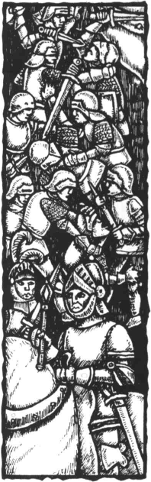
You can then carry out your first action in the Dynastic Sequence, finding out if your King and Queenproduced any children in 1300. As you will see from the rules, you can make three die rolls (and, if successful, produce three children), but there is the greater danger of the Queen dying if you roll more than once. If children are born, Character sheets have to be made out for them.
You*then have to make a Survival Roll for all adult characters. In effect, this means only your King and Queen in the first turn (and - optionally - not even the King, if you are not yet experienced players of this game). To survive, your King will have to roll 4 or more on two dice (his Constitution being normal). Your Queen will also have to roll 4 or more, although this might be 1 or 2 higher if you have tried more than once to obtain a child. Should the Queen die, you will have to wait until a bride is available when one of the children in the game reaches 15. If your King dies, oneofyourchild characters becomes ruler and a Regent is invented.
You then receive your Taxes of 5 Crowns per province, optionally boosting this to 7 Crowns a Province if you are prepared to run the greater risk of Rebellion. Unless you intend to be aggressive, or fear that another player might be, you would be well advised not to tax high in the first turn, as you run a very real risk of Rebellion. Once you have a Monarch with high Charisma, this risk is reduced.
You then buy your armies and fleets. The maximum you will be able to afford if you taxed normally is 10. In the rest of the game, Army counters are always brought on in the capital, but for the first turn they can be placed anywhere in the Kingdom - players should place their Army counters on the map in order. You might consider it wise to protect all your borders, as they are all vulnerable at this stage, and opponents need only send a single army into a vacant province to capture it. There is no secrecy. Also remember - once bought you cannot return them, nor can you buy more once players have started placing Army counters on the map.
Keep in mind that Blood Royale is not a wargame. If players continuously indulge in conflict, the winner will almost always be the player that stayed relatively peaceful. One has only to consider the economics to realise this. Each owned province brings in an income of 5 (or 7) Crowns per five years. Every Army counter raised to achieve this costs 5 Crowns, plus 2 Crowns for each turn's maintenance. Three (or four) Army counters garrisoning a captured Province against counter-attackcost more than can be raised in Tax. And each Army counter lost while capturing a province means an extra outlay of 3 Crowns (5 to raise troops tather than 2 to maintain) to replace when the time comes, not to mention the potential problems of having them out of the game for a whole turn.
But conflict will occur. A cheap victory may only have a marginal positive effect on your own economy, but it will have a much greater negative effect on your opponent's. Most conflict, however, will almost certainly be connected with securing trade. Each 5 year turn sees the introduction of up to 250 Crowns worth of Trade Items - 50 per player. If you loseout on trade, your chances of winning are slim. Even so, you should try to tie trade up with marriage contracts rather than combat.
Rebellion is a facet of the game that should never be underestimated. As was typical of the 14th century, armies abroad tended to lose everything they had gained by having to be brought home in order to put down unrest. Sending the Monarch abroad is always a danger, unless he or she is very high in Charisma.
So, what must you look for in a marriage contract? For certain countries - especially France - a non-aggression treaty with England is of considerable use. Armies are
limited and expensive, so a secure border is of major advantage.
At the same time, it is in other players' interests to prevent France from getting this security - and they might even consider having a contract with England that prevents France getting such an alliance.
Italy can also be troublesome, unless other players can persuade Spain, for example, to provide a permanent threat to Italy's south. And Italy is bound to be Germany's first target, given that Lombardy and Veneto are so close. The mere existence of such a threat forces Italy to keep troops at home
These are just a few examples of the need to secure borders and to give other players something to think about so that they leave you alone.
It will be seen that no single country in the game commands all of the three Basic Resources Items. They must trade. Furthermore, there are not enough Resource Items to go round. So, these deals should rate very highly on the list of priorities. Securing trade also means ensuring that you can get the goods to your capital. A player who regrets the terms of a Marriage Contract he agreed with you might minimise the effect by making it difficult for you to get the Resource Items home.
Do not underestimate in any way the power of such things as marriageable children with 12 Strength/Guile or daughters with + 2 Constitution. These place you in a strong bargaining position. Similarly, you are in a strong position if you are seeking a bride for your heir to the throne. Sometimes it is worth hanging on to these children rather than marrying them off early.
Although it is a temptation to have extra dice rolls for children, you must remember that - should the wife die - a most useful marriage contract will be terminated. Then again, maybe it gets you out of a bad one. There is one exception to this. The death of the original Queen does not terminate any contract and it is an advantage to have quite a large Royal Family early in the game.
OPTIONAL RULES
The following Optional Rules introduce new aspects to Blood Royale, which players of the game may find more challenging. It is recommended that all players enjoy several games before adopting any of these options.
The Optional Rules need not be taken in total. Players may introduce the ideas of Neutral Provinces, or Event Cards, or Governing Provinces, and exclude the other ideas in this section. Obviously, players should decide which rules they will choose to introduce before play commences. Make a note from the following checklist of which Optional Rules are in force at the beginning of the game, so that disputes can be settled.
Optional Rules
(A) Four Character Start
(B) Characteristic Rolls for all Starting
Characters
(C) Disputed Succession
(D) Movement of Trade Items
(E) Event Cards
(F) Neutral Provinces
(G) Governing Provinces
(H) Extra Event/Movement Phase
(I) Changing Capitals/Resource Areas
(A) The Four Character Start
To speed the development of the Dynastic Aspects of the game, each player begins with four characters instead of three. These are:
A King aged 30 (born in 1270)
A Queen aged 25 (born in 1275)
Two children, one aged 10 and one aged 5 (born 1290
and 1295 respectively)

These characters should be created before the game starts, in the normal fashion. The effect will be to make players negotiate marriages earlier in the game.

(B) Characteristic Rolls for the King and Queen
Instead of all the starting Kings and Queens having 'Normal' characteristics, players generate these in the normal way. Since it could be disastrous for a player to begin the game with a King or Queen with a low Constitution score, and then to have one of the initial parents die in the first round, this option should not be used unless players agree that no Survival rolls will be made for the King or Queen in the first round.
(C) Disputed Succession
The normal rules for succession allow players to pass over female characters and Princes imprisoned by other players. Otherwise, when a King dies, the next-in-line comes to the Throne. Players risk rebellion and long-term war through passing over a legitimate heir.
This principle can be extended to allow players to pass over any legitimate heir at the time a King dies. Players are still most likely to want to pass over the legitimate heir when it would lead to a female character who was married into another Dynasty or an imprisoned Prince coming to the throne. However, players might also wish to prevent a weak King coming to power, or to establish a junior, but more powerful branch of the royal family as the legitimate Dynasty.
The penalties for passing over a character are as outlined in Succession - Penalties for Passing Over a Legitimate Heir (9). All characters in the player's Dynasty fight with a -1 penalty to their Strength score for as long as the legitimate heir to the throne, or his or her heirs, is still alive. Additionally, the Dynasty controlling the rightful heir has a il bonus to Strength for all its characters whenever they are fighting the 'usurper' Dynasty.
As in the Basic Rules, if the passed-over character is one who could not have been passed over according to the basic rules of Succession, the new monarch also has a penalty to his or her Charisma score. This represents the followers of the 'deposed' character causing trouble. Once the decision has been made and the new Monarch is on the throne, the player should roll a die. A result of 1-3 means the new monarch's Charisma is reduced by -1, and a result of 4-6 reduces it by -2 (this may reduce the character's Charisma score to -3 or -4!). This penalty cannot be inherited by any of the new monarch's heirs, but can reduce the monarch's Charisma below -2.
This additional penalty is only taken if the character is not one who could have been passed over according to the normal rules of the game.
In all cases, the player controlling the 'deposed' character must pass the character (along with his or her spouse and any children) to the player on his or her left, to be controlled by that Dynasty from now on. The character is now in exile, and the receiving Dynasty receives the +1 Strength bonus fighting the 'usurper'. If the 'deposed' character already lives with another Dynasty (as a married woman), this rule does not apply.
(D) Movement of Trade Items
With this option, Trade Items are not actually moved about the board. Instead, during the Movement Phase, players may announce their intention to ship Trade Items from Province A to Province B. If no player objects, the player must then move the Trade Item as stated. If any player does object, the owning player must show which route he or she wishes the Trade Item to take. If he or she can show a route by which the Trade Item cannot be intercepted (see below), the movement of the Item takes place immediately. If the route can be intercepted, the players involved must resolve the interception
attempt(s) in the order in which they would occur along the route.
A Trade Item can be intercepted if it:
(a) Passes through a province which contains Army counters of another country;
(b) Passes through a sea area in which there are more Fleet counters of the intercepting country than of the owning country;
If an interception is possible, the owning player must throw one die, adding the following modifiers:
+1 for each intercepting Army counter;
-i- 2 for each intercepting Fleet counter (count these only if they are in excess of the number of the owning player's Fleet counters in the same Sea Area);
-1 for each 15 Crowns the owning player pays to the Treasury before the die roll; *
+1 for each 20 Crowns the intercepting player pays to the Treasury before the die roll.*
* The owning player should state how much he will spend before the intercepting player.
If the modified result is 6 or more, possession of the Trade Item passes to the intercepting player.
Trade Items may still not be moved through a province with a Famine or Rebellion marker; no route can be traced through such a province.
(E) Event Cards
The Event Die roll should be replaced with the drawing of an Event Card. The cards allow for a greater variety of events, and present the different countries with varying problems, opportunities and goals. If you use the Event Cards, you should either also use Optional Rule (H) -Governing Provinces - or be aware that certain cards refer to opportunities to inherit titles to certain Provinces. These cards should be read as allowing the characters a chance to gain marriageable characters, money or trade items, as appropriate.
During the Events section of the Movement Phase, the first player (determined at the beginning of the Movement Phase) should draw a card. The instructions on the card should be followed precisely.
Cards which have long-term effects should be kept by the player until all the instructions on the card have been followed. When this has occurred, the card should be placed on a discard pile.
Certain concepts introduced by the cards are further discussed below:
Shuffles
Certain cards instruct the drawing player to shuffle the Event Cards. When he or she has completed all the instructions on the card (or as many as possible), the player should gather the remaining Event Cards and the discard deck, shuffle them together, and replace them face down.
Rebellions
If rule (G) regarding Titles and Governing Provinces are being used, the Rebellion die roll should also be modified by the Charisma scores of both the Governor and his wife (if the Governor is indeedmale; the same does not apply if the Governor is female).
The Rebellion roll in the Capital should be modified by the scores of all Princes present. If the result is a Rebellion,

half of that country's current cash in hand should be returned to the Treasury. This only applies to the Capital.
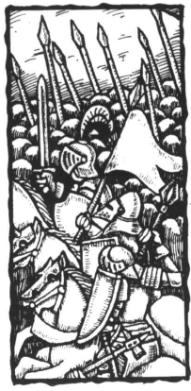
If a neutral province is indicated by the Random Provinces Table, that rebellion does not take place. Do not re-roll on the Random Provinces Table.
Trade Items cannot trace a route through a Province carrying a Rebellion marker.
Storms
Maity of the Event Cards have a reference on the bottom to Storms, followed by a range of numbers (1, 1-2, etc). If a card with such a reference is drawn during the Events Phase, roll one die. If the result falls within the range on the card, the Storms Event will occur in addition to the Event on the card. See the Basic Rules.
Bidding and Investing
On several of the Event Cards, players are given the option to bid or invest Crowns in order to make an Event happen or to stop it from happening. Note the distinction between the two.
Bidding means that all the players, starting with the player who drew the card and proceeding clockwise, should take part in an auction; one player will succeed when all the others have passed. The winning player has the advantage of the card, and should pay the sum in Crowns he or she bid to the Treasury.
Investing means that all the players should secretly record how many Crowns they wish to spend to secure the advantage from the card, and these amounts should be revealed simultaneously. The player investing the largest amount has the advantage of the card. All players then pay the amount of the investment in Crowns to the Treasury.
Inheritance of Neutral Provinces /Kingdoms
Certain Event Cards allow Dynasties to 'take control' of Provinces and Kingdoms not normally involved in the game through marriage. Players invest Resource Items or Crowns to attract a marriage which will allow one of them to inherit the title of that Province/Kingdom.
All such titles introduced into the game in this way can be inherited in the normal way (see Governing Provinces (H)). A player whose Dynasty already included the King of England could take advantage of card 31 and have the same character - or another - marry the heir to the King of Denmark.
With cards 31 and 33, players invest Crowns to make the match, and the rules for Investing (above) should be followed. For cards 30 and 32, players invest Resource Items. For the purposes of these cards, all Resource Items count equally.
Also regarding cards 30 and 32, the titles to be inherited are for Provinces normally part of another player's Kingdom - namely, Spain. If the Optional Rules for Governing Provinces are being used, the title being granted is a 'noble' title, and final control of the province continues to rest with the existing reigning monarch (see Governing Provinces (G)). If a Governor already exists for the Province, the card is ignored.
Finally, for cards 31 and 33, as well as creating character sheets for the Prince, the successful player may also place a Royal Piece on the board in his or her Capital, following the normal rules. This Prince can lead armies, Govern Provinces, etc. However, no children should be produced for the marriage; these are assumed to be part of the ruling Danish/Polish Dynasty, not the player's.
Fighting Neutrals
If the rules for Neutral Provinces are used, players may find themselves wishing to wage war against them. Also,
the arrival of the Free Companies, or other military events inspired by Event Cards, might draw them into war with forces which are not under the control of another player.
Whenever a player has to fight a battle with a Neutral Army, the Neutral Army counters should be used. The player to the left of the player involved in the battle should roll the dice for the Neutral Army.
Unless directed by Event Cards, Neutral Armies never move from the Province in which they start. Unless Event Cards say otherwise, Neutral Armies always defend, never retreat and never surrender. If they capture a Royal character, Neutrals ransom him for 100 Crowns.
For Event Card 3, Free Companies, roll one die and halve the score, rounding up. This is the number of Free Companies available. They remain upon the board until destroyed in Combat or by Plague.
For Event Cards 10 - War With the Welsh, 11 - War With the Swabians, 12 War With the Burgundians, 13 - War With Aragon and 14 - War With the Moors, the number of Neutral Armies that appear is stated on the card. At the end of the last Movement Phase in that turn, these counters are removed. If a Neutral conquers a Province, that Province becomes Neutral as well.
For Event Cards 51 - Albigensian Crusade and 61 - Crusade, the number of Neutral Armies that appear is stated on the card. The Cathar rebels remain until the end of the last Movement Phase in that turn; unless defeated, the Cathars will make the Dauphine a Neutral Province. The Saracens should be removed at the end of the last Movement Phase in that turn.
Pretenders and Bastards
Cards 18-22 allow for characters to leave the Dynasty of their birth, and join another player's characters. The character sheet should be passed to the player on the left, and a Royal playing piece of the appropriate Dynasty substituted. Characters can only become Pretenders if they are at least 15 years old, and if they are not the only male child of the monarch. A Pretender's wife (though not a husband, who should be returned to his original Dynasty) and any children less than 15 years old should alsobepassedtothe player on the left. The new owning player may use the character as if he or she were a member of his/her own Dynasty from then on, perhaps even marrying the character to someone in his own Dynasty (no Marriage Contract would be made).
For a 'bribe' of 50 Crowns, the Pretender's original Dynasty may 'buy back' the character, his wife and any children. All sins are forgiven.
A Pretender character or any of his or her heirs may inherit the throne through the normal rules while still controlled by a 'foreign' Dynasty (the 'claim' should be inherited in exactly the same way as any normal title). The player who has been controlling the disputed country up to that point may pass over the Pretender's claim (see Succession (9) and Optional Rule (C) above), or becomes a Baronial player in the normal way.
If a player controlling a Pretender actually managed to conquer the whole of the disputed country by military means, he or she could either set the Pretender up as a separate monarch (still controlled by that Dynasty, of course), or play safe and rule the conquered area just like any other. Pretenders rarely get what they think they deserve...
Cards 38 and 39 allow for the creation of bastard sons of unmarried Kings. These characters are passed to the player on the right, who controls them from now on. Any time the character lands ina Province of his father's Kingdoms, there is an immediate Rebellion roll. If a female character ever comes to the throne while the bastard lives, every Province in the Kingdom must be checked for Rebellion.

Bastards' claims can never be inherited, even though the character can marry and have children. The player operating the character may control the character as he or she wishes, including marrying the character to a female in his or her own Dynasty.
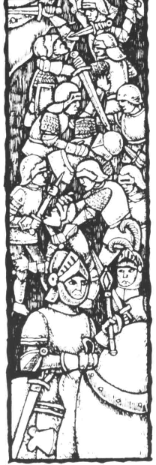
(F) Neutral Provinces
Neutral Provinces are those which are controlled by none of the players in a game. With this option, ten such Provinces are marked at the beginning of the game, using the Neutral markers. These are:
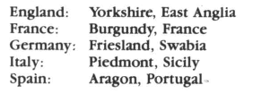
Neutral Provinces may also be created during the course of the game. Certain Event Cards may, in the right circumstances, cause a Province to become Neutral.
All Neutral Provinces are considered to have a garrison. When a Province is invaded, place two Neutral Army counters on the map in the relevant Province. This force will defend the Province, with the player to the left of the invader making dice rolls on its behalf. The Province cannot be occupied until both the defending Army counters are defeated.
If the Province would have been part of that player's country in the Basic Game, it becomes a Home Province after conquest.
Neutral Provinces do not raise taxes. They do not raise Resource Items, or allow them to be transported through. They do not invade neighbouring Provinces, unless directed to do so by an Event Card.
Once conquered, a Province which has been Neutral is subject to the normal rules.
(G) Governing Provinces
This optional rule allows players to make more use of their Prince characters, without having to go to war.
At any time during the Dynastic Phase, or as directed by an Event Card, a player may choose to bring a Province into the direct ownership of his or her Dynastic house by making a Prince the 'Governor' of the Province. To do this, the player announces which character will be given the title, and which Province the decision affects. The Province must be one controlled by the player at that moment. Only a Prince (aged at least 15) can be created Governor of a Province (unless directed by an Event card; also, female characters and children may inherit the title later, following the normal rules for inheritance).
Note: All Provinces not so Governed are considered to be under the direct control of the King for the purposes of this game, and the normal game rules continue to apply.
The player should record on the Character Sheet that that Prince now holds a noble title - this should read something like Duke of Liguria, Earl of Wessex, etc.
This title may be inherited in exactly the same way as the rank of King, following the rules of Succession. This may cause the title to leave the Dynasty in which it started, and may even lead to a situation where a Province is governed by Prince of one Dynasty, and controlled by the King of another.
The rules for Succession (see Basic Game (9)) do not apply in the following areas. The King of the relevant country (ie, that in which the Province is situated at the time) may choose to dispute the normal succession. If this only affects the player's own Dynasty (ie, the Province is governed by a member of the same Dynasty as the King), a Rebellion marker should be placed on that Province, but otherwise the King's wishes are followed. If the disputed succession involves another player's Dynasty, then not only is the Rebellion marker placed in that
Province, but Rebellion Die Rolls must be made, with normal modifiers, for the whole Kingdom. Medieval nobles were very careful about their rights when it came to the Crown - even if this meant 'sticking up' for foreigners!
Characters may Govern more than one Province.
If a minor inherits a title, the 'Regent' will be monarch. No new character is created.
Titles and Governorship to a Province affect the game in the following areas:
Characteristics
Raising Taxes
Commanding Troops
Raising Trade Items
Events
Characteristics
The player should immediately give the character a +1 bonus to his or her Strength/Guile characteristic. This may take the characteristic above +2. This bonus may only be taken once, no matter how many Provinces the character Governs.
Raising Taxes in a Governed Province
In a medieval country, taxes were mostly gathered on behalf of the monarch by Provincial nobility. This gives the noble some power, since he or she may raise local taxes by the same authority, and could even choose to withhold all or some of the tax revenue from the monarch.
With this option, the King of each country sets the rate of tax for the whole country as usual. However, any Province governed by a character raises 2 Crowns extra (ie, either 7 or 9 Crowns).
A Provincial Governor from a foreign Dynasty would keep those 2 Crowns for his or her own Dynasty. The Governor may also refuse to pay all or some of the 5 or 7 Crowns Royal Taxes for that Province to the Crown, in which case the governing player should take the money from the Treasury. There is no penalty for doing so (except that the King isn't likely to be very grateful...).
Also, whenever the Provincial Lord is actually present in that Province, the taxes raised from there should be modified by his or her Charisma. This additional profit/loss being taken by the governing player.
Commanding Troops in a Governed Province
The rules for Maintaining and Raising Armies remain the same as for the Basic Game, However, the Governor of a Province is considered to be the commander of any Army counters located in that Province. So long as the Governor is a Prince aged 15 +, is present with the Army counters, and so long as the King is not, the Governor controls the Army counters for the purposes of Movement and Combat, even if this means the Army is under the control of a foreign Prince.
A Provincial Governor in command of such Army counters may either obey the instructions of his or her monarch, in which case the Movement turn will proceed as normal, or he or she may disobey. A Provincial Governor does not have complete control over these troops, however, and may only command them while they remain in the Province. If they move further than this, the Army counters revert to the control of the King.
Raising Trade Items in a Governed Province
In a Resource Area Province, a Governor may raise more than one Trade Item during the Interphase, or may hinder trade to such an extent that Trade Items are lost. This may only occur if the Governor is present in the Province. A dice should be thrown during the Raise Trade Items part of the Interphase, and the Governor's Charisma should be added to it. If the result is 7 or more, the Province produces an additional Trade Item, which should be placed there immediately. If the result is 0 or less, the normal production in the Province is affected, and the normal Trade Item is not placed.

Events in a Governed Province
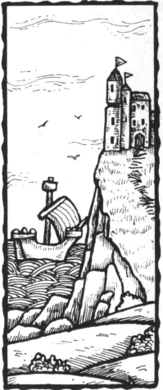
A Governor is presumed to live in the Province or Provinces he or she controls for some or all of the 5-Year Turn. Therefore, if an Event occurs in a Province, it should be assumed that it affects the Governor, and his or her family as well, if applicable.
If a Plague event occursinsucha Province, the Governor, his or her wife or husband, and any children aged 15 or younger, must make Survival Rolls. The player should add 1 to the dice roll for each additional Province the GoTernor controls that is not affected by Plague.
If a Rebellion event occurs, the Governor's Charisma will count as a modifier in the Province in which he or she is located. However, it should also be used as a modifier in the Governed Province, as should that of the Governor's spouse.
(H) Extra Event/Movement Phase
With this Option, a third Event/Movement Phase is introduced .This option allows for more Movement and Combat. The third Phase is conducted in the same way as the normal two.
(I) Changing Initial Capitals and/or Resource Areas
After a while players may find that they are becoming too accustomed to the normal pattern of play in game. This might prove to be a particular disadvantage when a new player joins a group of more experienced players.
One way of revitalising the game is to move the locations of the Resource Areas andfor Capitals. By doing so, players will change the emphasis of different Provinces, and open up many new possibilities.
The Capital Markers, and the special Resource Item counters are used for this Option. Resource Areas should be changed before Capitals. Obviously the markers actually on the map are redundant with this option.
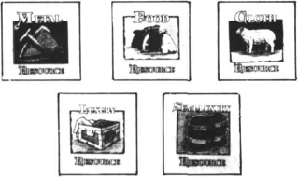
The Resource Areas are changed by using the Random Provinces table (see Events (14)). Roll a six-sided and the ten-sided die to generate the location of each Resource Area, obeying the following rules.
(i) Place the Luxury Resource Area first, then the Semi-Luxury areas, then the Cloth, Metals and Food areas.
(ii) No Province may have more than one Marker.
(iii) No country may have more than three Markers of all types, and no country can have a full set of the three basic resources.
(iv) The Luxury and the two Semi-luxury Markers must be in three different countries.
(v) No country should have more than 2 Basic Resources of the same type.
If the Capitals are to be moved, the same system is used with the additional rule that the Capital may not be placed in a Province in which there is a Resource Area.
If the rules for Neutral Provinces are being used, players must agree what will happen if a Resource Area is relocated in a Neutral Province
Design Notes - The Optional Rules and Strategy Hints
More than anything else, what you can achieve by negotiation and diplomacy will be longer lasting than what you can achieve by military means. Trade can be conducted swiftly over long distances, reducing the necessity for military adventure to secure trade routes, and the efficient governing of provinces will depend even more on the quality of the marriages you have arranged. There is a finite capacity for each country to expand; once that is reached, there are no reserves with which you can hold off attacks. Therefore, the collapse of a militarily aggressive country is often much more spectacular than its rise.
However, in the early turns, the obvious target for aggression are the Neutral Provinces you can turn into Home Provinces (Yorkshire and East Anglia for England, and soon). Because these are only defended with 2 Army counters each (the Neutral army), and each player can deploy up to 8 at the beginning of the game, it is obvious that you can outnumber any neutral Province's army easily. However, without any Marriage Contracts, nobody can afford to trust the other players. While Germany lines up to invade Swabia, Italy might take Bavaria and France Lorraine. Neither of these Provinces would have any garrison.
So, be prepared to wait if you don't think you can trust the others. After three turns, you should have the capacity to bring your army up to full strength and the insurance of one or two Marriage Contracts.
At the same time, don't ignore the Neutrals. The continental ones are in important locations, and the tax is going to be useful in a longer game. Also, Swabia, Burgundy, Aragon and Granada have Event Cards which turn them into aggressive states. Aragon is the odd one out in this foursome; although it is a 'Spanish' Province, it directs its aggression against Italy (Sicily). A reason for Italy to interfere in Spain?
Other Provinces have important roles in the Event Cards as well. It isn't 'unsporting' for players to be aware of the places where Famine is more of a threat or that Aragon and Portugal can be gained through marriage. Some Provinces are definitely more desirable than others, but no two games of Blood Royale will have the same Provinces at centre-stage.
The rules for Titles and Governed Provinces allow for interesting decisions. A + 2 Charisma/-2 Strength Prince isn't any use in a war, but as Governor of one or more Provinces is going to be very useful. Extra tax revenues, possibly extra Resource Items, and the lesser likelihood of Rebellion might lead to more much-needed income. The problem would be if the Prince had an heir with -2 Charisma, or - worse, perhaps - the 'Duchy' was inherited by a rival Dynasty. Suddenly that income is partially controlled by somebody else, and the only time you can risk stopping it is when you have a + 2 Charisma King or a large, idle army.
Note that the rule about Rebellions in the capital means that it is risky just keeping the useless members of the family at home. If Rebellion breaks out in the capital, half your cash must be returned to the Treasury.
Finally, a few tips for the playing of each country:
England: England is normally a sure bet for the militarily unadventurous, particularly since the Scots, the Welsh and a few rebellions will normally make life very hazardous if troops are overseas. Without a long land frontier, it isasafe bet that invasion will beararity. England might - therefore - be the country to gamble on attacking its neighbouring neutral Provinces (Yorkshire and East Anglia) first, sheltering behind a strong fleet and an

alliance with France or Germany. Calais is a problem. Either secure it by a Marriage Contract with France, or forget it, unless your plan is to expand in France. Keep France and Germany off your back or (better) at war with each other, and make a treaty with Spain or Germany for those important cloth items (either would love your food surplus). If you must venture overseas, attack Bordeaux while France is at war with Germany, or Andalusia while Spain is occupied elsewhere.
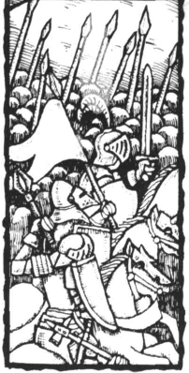
France: France needs allies, and your policy has to be to secure at least two of those borders against attack. England might be one to approach; after all, you aren't going to gain much from an early war, except Calais. Your second choice ought to be dictated by the defence of your Resource Areas. The Dauphine is very exposed - beware of an Italian-Spanish alliance or (worse!) a German-Spanish marriage. Bordeaux and Aquitaine are very tempting for Spain, also. Either make an alliance with Spain (you need Metals and Spain needs Food) and go east (if you intend to be aggressive at all), or find some way to fend off England, Italy and Germany while you go all out for Spain, possibly with Italianhelp (you don't actually need that Semi-Luxury in La Mancha; Italy is not a natural trading ally since you are both looking for metals, but the Italians need some guarantee against Germany). The neutral Provinces, Flanders and Burgundy, might be best left as buffers for a while at the beginning; if you are going to be warlike, try and reduce the threat on one of those borders.
Germany: The big temptation is to go for that Luxury in Venice. Even if you don't actually move troops after it, you can use your presence to bully Italy into an advantageous deal for Luxuries and Food in exchange for Metals. You only need Italy as an ally if you are going to invade England and don't want your back stabbed. On the other hand, a quickly weakened Italy, with Venice and Lombardy in German hands, would leave you very strong for phase two. Alternatively, you can either attack your other natural enemy, France, to make sure Lorraine is secure and to steal the Dauphine, or make the surprise move into England. Whichever, you must make sure Italy and France are not allied, and you must use your surplus Metal to get Food, either from Italy or France. Bottle up one, and deal with the other; that is the simple basis for German strategy. The neutrals should only be taken as part of that strategy; Swabia is in the heart of the main trouble zone in the game, around Swabia, Burgundy and Piedmont.
Italy: Once the big problem of Germany is solved, Italy can look forward to some opportunities. Those Luxuries from Venice are going to be in big demand. An alliance with Spain to supply Luxuries for Semi- Luxuries and Metals might be a big money-spinner, but virtually any country which quickly collects sets of four Trade Items will want to talk with you. Italy can easily get by without war, but must beware the threat of invasion. Be particularly aware of German-Spanish alliances. France is not a natural trading ally, but a military alliance might be necessary, and you can always swap Luxuries for Semi-
Luxuries. If you are going to be aggressive, you need to ally with one of your northern neighbours against the other, although it is possible to have some spectacular successes by a sudden attack on an otherwise occupied Spain. If things are quiet, snatch Sicily, which no-one will mind. Only try for Piedmont if you are allied with France or Germany and they don't feel threatened.
Spain: You should be looking for Food and Luxury Items to win the game, which makes your normal focus of attention go towards Aquitaine or a trade deal with England or Italy. If the military option is preferred, the classic strategy is to ally with Germany and sieze Angouleme - cutting off the Dauphine and facing France with war on two fronts. Then take Aquitaine, and stop there, before Germany gets too close. The alternatives for adventurous players are sea invasions of Italy or England. The former isn't very attractive- Germany will move on Venice and Lombardy, with the Trade Items you want, if it sees Italy crumble - but it might be easy territory to conquer. All that Food in England is an unbearable temptation, and you can certainly not afford England to just sit there and reap trading profits. But Spain does have a problem then if rebellions break out...
Some Tips For Naming Dynasties and Characters
England - Dynastic Names
Plantagenet, Tudor, York, Lancaster, Essex, Percy
Christian Names
Edward, John, Edmund, Alfred, William, Stephen
Mary, Elizabeth, Anne, Mary, Maud, Mathilde
France - Dynastic Names
Anjou, Martel, Bourbon, Guise, Angevin, Nevers
Christian Names
Jean, Louis, William, Robert, Charles, Henri
Louise, Marie, Charlotte, Isabelle, Odette, Philippa
Germany - Dynastic Names
Hapsburg, Welf, Wettin, Wittlesbach, Hohenzollern,
Luxemburg
Christian Names
Maximillian, Charles, Ferdinand, Frederick, Karl,
Wilhelm
Anna, Mary, Florenz, Catharine, Elizabet, Mathilde
Italy - Dynastic Names
Visconti, Medici, Ordelaffi, Orsini, Savoy, Sforza
Christian Names
Luigi, Giovanni, Giuseppe, Bernadino, Bartolomeo,
Francis
Carlotta, Julianna, Maria, Anna, Blanche, Joanna
Spain - Dynastic Names
de Silva, de Idiaquez, Fajardo, de Mendoza, de Guzman,
Toledo
Christian Names
Juan, Fernando, Carlos, Francisco, Sebastian, Miguel
Carlotta, Isabella, Maria, Jeanne, Eugenia, Sofia



