Agenda
- Make the world fantastic
- Fill the characters’ lives with adventure
- Play to find out what happens

Questions
- How did you first hear?
- Which of you has a special reason to ?
- Why did the Patron hire your party to destroy?
- What has the Patron threatened will happen to each of you if you don’t destroy?
- X
- x

Impressions
- x
- x
- x
- x
- The soundlessly flight of an
- X
- X
- X
- X
- X
- X
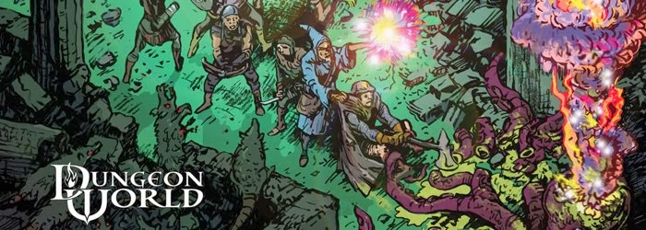

Dungeon Starter v1.0a
A Dungeon Starter by Jerry Dungeon Master
For Sage LaTorra and Adam Koebel’s
Dungeon World
www.Dungeon-World.com

Goals
- Establish details, describe
- Use what they give you
- Ask questions
- Leave blanks
- Look for interesting facts
- Help the players understand the moves
- Give each character a chance to shine
- Introduce NPC’s
- Fill out your worksheet

Dungeon Moves
- Change the environment
- Point to a looming threat
- Introduce a new faction or type of creature
- Use a threat from an existing faction or type of creature
- Make them backtrack
- Present riches at a price
- Present a challenge to one of the characters

The greatest quote I've ever seen about Dungeon World "If you have not played DW yet, it is because you are a piece of xxxx and I hate you."
-----The Cookie Monster

Custom Moves
X
X
X
X
X
X
X
X
X
X
X
X
X
X
X
X
X
X
X
X
X

THINGS
X
X
X
X
X
X
X
x
X
X
Services
X
X
X
X
X
X
X
x
Spells

X
X
X
X
X
X
Monsters
Bandit Horde, Stealthy, Organized, Intelligent, Hoarder Sword (b [2d4] damage) 3 HP 1 armor Close, Far Instinct: Gain Money
•Rob and pillage
•Pickpocket
•Ambush - Summon 2 more bandits once per encounter per group
X
X
X
X
X
X
X
X
Xx
X
X
X
X
X

X
Player: I sneak across the bridge.
GM: Okay Perkin's you head out over the chasm as quiet as can be. Why don't you make that Defy Danger roll using DEX please?
Perkins: An 8!
GM: Okay, as you get about halfway there you see a nasty ogre rise up at the far end (Worse outcome). He hasn't seen you yet, what do you do?

GM notes:

Inspirations: Mark Tygart’s Awesome Dungeon Starters

