DBA 3.0 + Hordes of the Things 2.1
D3H2

INTRODUCTION
The following set of additional rules allows players to add elements of Hordes of the Things to DBA 3.0. Most rules are exactly the same as DBA 3.0 as indicated below, just substitute those sections of the rules from the DBA 3.0 rule book. Areas that require changes (some quite minor) are set out in full. You must purchase the DBA 3.0 rule book to use these rules.

TROOP DEFINITIONS
Troops are defined by battlefield behaviour instead of the usual formation, armour, weapons and morale classes.
Aerials troop types are: Gods, Dragons, Airboats, Flyers or Aerial Heroes.
Mounted troop types are: Knights, Cavalry, Light Horse, Scythed Chariots, Camels, Heroes, Paladins, Behemoths or Beasts.
Foot troop types are: Spears, Pikes, Blades, Auxilia, Bows, Psiloi, Warband, Hordes, Artillery, War Wagons, Shooters, Sneakers, Mages, Command Post or Clerics.
In addition, any troop type (except Artillery, Camels, Heroes, Paladins, Clerics, Mages, 4Kn, 6Cv, 6Kn, 8Bow, 8Spear, Scythed Chariots and Aerials) may be fielded as “Fast” gaining increased movement at the cost of some staying power. Psiloi are already considered Fast and so do not gain increased speed.
A few army lists permit some of their Mounted elements to “dismount” i.e. be exchanged for a related Foot element during the game by using a complete single element tactical move to dismount, but cannot remount. More armies have Mounted elements that can be deployed either mounted or dismounted at the start of a game. A very few have Mounted Infantry (prefixed by “Mtd”). Though based on larger bases with their mounts, they fight as their Foot type, but have a Movement Allowance of 3BW and can move more than once during a bound.
Following the rules are tables for both Combat Factors and Combat Outcomes that use only the traditional HOTT elements with a few exceptions. Use these tables if you do not wish to include all the historical element types from DBA.

BASING YOUR FIGURES AND MODELS
All figures must be combined into elements of several figures, or an elephant, vehicle or artillery model, fixed to a thin rectangular base. Base width is critical and must not be changed. It is 60mm for 25+mm figures and 40mm for smaller figures. Depth is less important and can vary to accommodate bulky figures. Generally larger figures and models are mounted on large bases with a depth of 60-120mm for 25+mm and 40-80mm for anything smaller. Figures riding some sort of horse sized beast are mounted on medium bases with a depth of 40-60mm for 25mm+ and 40-80mm for anything smaller. Finally, Foot figures are mounted on small bases with a depth of 20-30mm for 25mm+ and 15-20mm for anything smaller.

Large Base Depth (25mm+: 60-120mm; all others: 40-80mm)
Troop Type: List Code #Figures
Dragon/God Dg/Gd 1 model
Airboat Ab 1 model
Behemoth Bh 1-3
Knight Wedge/Beasts 6Kn/Bs 3-6 (recommend 3 for Bs)
Chariots HCh/LCh/SCh 1 model
Artillery Art 1-2 models
War Wagon WWg 1 model
Command Post CP 1 Model + 2-4 figures

Medium Base Depth (25mm+: 40-60mm; all others: 30-40mm)
Troop Type: List Code #Figures
Knights Kn 2-3 (recommend 3)
Light Horse Lh 1-2 (recommend 2)
Flyers Fl 1-4
Cavalry Cv 2-3 (recommend 3)
Camelry Cm 2-3 (recommend 3)
Heroes/Paladins/Clerics Hr/Pl/Cl 1-3
Mages Mg 1-4
Hordes Hd Many
Double Ranked Foot 8Bw/8Sp/6Blade 6-8 in two ranks

Small Base Depth (25mm+: 20-30mm; all others: 15-20mm)
Troop Type: List Code #Figures
Spears/Pikes/Blades Sp/Pk/Bl 3-4 (recommend 4)
Auxilia/Bows/Shooters Aux/Bw/Sh 3-4 (recommend 3)
Psiloi/Lurkers Ps/Lk 1-2 (recommend 2)
Warband/Sneakers Wb/Sk 3-4 (recommend 3)

The general's element must be recognisable by his figure, standard or conventional white charger, or rarely by being in a litter or command wagon. Fast Troop Types can be based on deeper bases to help distinguish them. For example, in 25mm scale if you base normal Foot on 20mm deep bases you can base the Fast equivalent on 30mm deep bases.

ELEMENT COST
Type | Cost per Element
Aerial Hero | 6
God, Dragon, Paladin, Mage, Behemoth, other Hero | 4
Airboat, Artillery, Cleric, War Wagons, most double elements (6Cv, 6Kn, 8Spear, 6Blade) | 3
Beasts, Blades, Camelry, Flyers, Knights, Cavalry, Spears, Shooters, Command Post, 8Bw, Sneakers | 2
Pikes, Auxilia, Warband, Bows, Inexhaustible Hordes, Light Horse, Lurker Psiloi | 1.5
Other Hordes, Psiloi, Scythed Chariots | 1

First decide on how many Army Points (AP) each side receives then use the table above to construct an Army by spending these AP on elements. Generally, 24 AP per player will produce a DBA sized battle of around 12 elements. Up to half an army’s AP can be spent on 6 or 4 Point elements; the rest must be spent on 3, 2 or 1 point elements. All armies receive a free General. Some armies can expend up to 6 AP to buy elements of another army listed as Allies. Most element types can be fielded as “Fast” at no additional point cost.

BATTLEFIELD TERRAIN
Players must be able to provide a battlefield in case they become the defender.
Unless a competition organiser provides pre-set terrain, the battlefield is produced by the defending player placing separate terrain features on a flat board or cloth representing flat good going such as pasture, open fields, steppe grassland or smooth desert. The defender bisects the battlefield twice at right angles to its edge to produce 4 equal quarters and numbers these 1-4 clockwise from the left.
CHOOSING AND PLACING FEATURES
Same as DBA 3.0 but players may select any general terrain type as their home terrain.
If terrain is: | Compulsory | Optional Linear | Optional Rough | Optional Bad Going | Optional Others
ARABLE | 1 BUA  or  2 Plough | River (1 only)  Road  Waterway (1 only) | Enclosures  Scrub  Boggy | Difficult Hills  Woods | Gentle Hills  Plough
FOREST | 1-2 Woods | River (1 only) |  | Marsh  Woods | Gentle Hills  BUA (1 only)
HILLY | 1-2 Difficult Hills | River (1 only)  Road |  | Woods  Difficult Hills | BUA (1 only)
STEPPE | 1-2 Gentle Hills | River (1 only)  Gully (1 only) | Scrub  Rocky |  | BUA (1 only)
DRY | 1-2 Rocky  or  1-2 Scrub |  |  | Dunes  Difficult Hills  Oasis (1 only) | BUA (1 only)
TROPICAL | 1-2 Woods | River (1 only)  Gully (1 only)  Road | Enclosures | Marsh  Woods | BUA (1 only)
LITTORAL | 1 Waterway | Road  River (1 only) |  | Difficult Hills or Marsh  Woods or Dunes | BUA (1 only)

BUILT UP AREA
If a BUA (Built-Up Area) is chosen, it must be a Stronghold or Hamlet.
- STRONGHOLD has defensive walls (both magical and mundane), high economic or prestige value and a built in garrison that defends it. It must be in good going (except Plough) on the rear edge of its side’s deployment area or on a waterway or beach. The defender may declare a Stronghold to be their Camp. A Stronghold must fit inside an imaginary rectangle 6BW X 6BW and can be no smaller than an imaginary square 2BW X 2BW and must have a gate. It is placed like other area features, except that all of a Fort must be within 6BW of each of 2 battlefield edges and can be on a hill.
- HAMLET - either a small inhabited area of scattered or grouped houses among small enclosed fields, or a larger village or town with denser housing, but no perimeter defences except fences to keep out animals. It has insignificant economic or defensive value and its inhabitants fled when troops approached. It is placed as an area terrain feature and functions only as rough going.
A Stronghold may be garrisoned by 1 (non-allied) element [except Aerials, Sneakers, Behemoths or Scythed Chariots], placed near its centre but representing defenders manning its perimeter. If the garrison is Artillery, its shooting effect is reduced because the artillery is distributed around the perimeter.
A garrison or other occupying element can vacate a Stronghold voluntarily by a tactical move, but does not pursue defeated attackers. Occupiers of a Stronghold beside any but a paltry river count as defending the bank against enemy elements assaulting it and still partly in that river. Occupiers of a Stronghold/Fort cannot count as uphill of attackers or assaulters as fighting in bad going, since a hill counts as part of its defences. Denizens are not used in D3H2 (if you want a “Denizen” buy a Horde and put it in the Stronghold).

CAMPS
The Camp is the logistical heart of the army. An Army must have one unless it has a Stronghold or more than 2 War Wagons. It must be in good going (except Plough) on the rear edge of its side’s deployment area or on a waterway or beach. A defender may declare a Stronghold to be their Camp.
A Camp must be at least 1 BW long and fit into a rectangle the length plus width of which totals no more than 4 BW. A camp can be hollow with an interior space that can be occupied by a single removable defending troop or permanently occupied by fixed camp followers with tents, fires and similar.
Your Camp can be occupied either (a) by 1 only non-allied troop element [except Aerials, Sneakers, Behemoths or Scythed Chariots], which can vacate it or be replaced by another such element, or (b) by camp followers (represented by figures within the Camp). A Camp that has been entered by any enemy element either as a tactical or outcome move is immediately sacked and ceases to have any defensive or other value.
Note: Camp Followers as a separate element are not used in D3H2 (if you want a mobile Camp Follower buy a Horde and put it in the Camp).

FIGHTING THE BATTLE

DEPLOYMENT
Each side dices and adds the aggression factor of its army list to the score. The side with the lower total is the defender. It chooses and places terrain allowed to its army to create the battlefield. The high scorer is the invader. If the defender has placed a Stronghold, the invader’s base edge must be the opposite. Otherwise if the defender has used a road, the invader’s base edge must be one of the edges the road joins. If neither applies, the invader can choose any edge as his base edge except that opposite a waterway. The defender’s base edge is that opposite the invaders.

Both sides now place their Camps (if needed), the defender first. The defender now deploys its troop elements, and then the invader deploys its elements. 1 element of Foot may be deployed as the garrison of a friendly Stronghold. All other troops must deploy at least 3 BW from the battlefield centre line and 1 BW from any enemy Stronghold. Aerials, Beasts, Sneakers, Cavalry, Light Horse, Auxilia or Psiloi must deploy at least 2 BW away from battlefield side edges and others at least 4 BW away. Gods, Dragons and Psiloi optionally held off as Lurkers cannot be deployed and are summoned using PIPs instead.
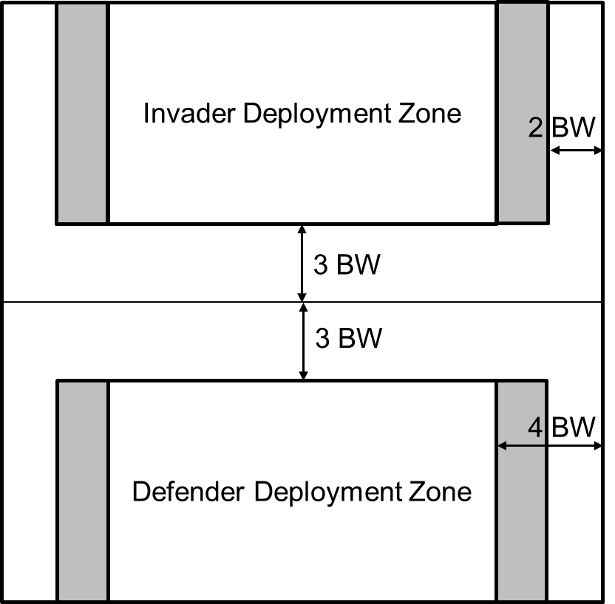

SEQUENCE OF PLAY
The defender takes first bound, then the two sides alternate bounds. During each player's bound:
- The player dices for Player Initiative Points (PIPs).
- The player can use PIPS to deploy Gods, Dragons or Lurker Psiloi, desorcell a Hero or Mage or replace Inexhaustible Hordes.
- The player can use any remaining PIPs to make tactical moves.
- The player’s Mages can bespell (using remaining PIPs). Artillery, War Wagons, Shooter or Bows elements of both sides that are eligible to do so, must shoot once each (in case of dispute in the order the moving player decides) and make or inflict outcome moves.
- Any elements of both sides whose front edges are in suitable contact with enemy fight in close combat in the order the moving player decides and make or inflict outcome moves.

PLAYER INITIATIVE POINT DICING
The side starts its bound by dicing. The score is the number of Player Initiative Points (PIPs) that can be used this bound. Any unused PIPs are lost, not kept for future bounds.
The first move each bound of each single element or column uses 0 PIPs if:
- it is entirely by road, and
- it is the full tactical move distance possible (or contacts friendly or enemy elements), and
- it moves only forward (even if an individual element move).
Each other tactical move uses up 1 PIP.
Except in the side’s 1st bound, a move that uses a PIP uses up an extra PIP for each of the 2 cases following that apply:
- If the element or group to be moved includes any Mages, Aerials, Scythed Chariots, Behemoths, Hordes, War Wagons, Artillery, or is an element currently garrisoning a Stronghold or Camp.
- If its general’s element has been lost or is entirely in a BUA, Camp, Wood, Oasis, Marsh or Gully; or if the element or group to be moved starts more than command distance from its general. Command distance is 20 BW if entirely Light Horse. Otherwise, it is 8 BW, except that this is reduced to 4 BW if entirely either beyond the crest of a Hill, beyond a BUA or a camp, on or beyond a Difficult Hill, or in or beyond a Wood, Oasis or Dunes.

SUMMONING GODS, DRAGONS AND PSILOI LURKERS

Gods, Dragons and Lurker Psiloi are not initially deployed but instead must be summoned using PIPs. It costs 6 PIPs to summon a God or all Dragons in an army (but not those of an Ally). Psiloi can be optionally held off board and deployed as Lurkers which can only be summoned on the first friendly bound after an enemy element has entered or deployed in Bad Going. It costs 1 PIP to summon a Lurker Psiloi the first time, 2 the second time and 3 for the third and last time. Dragons and Gods that have Fled off the board may be re-summoned. Summoned elements appear as follows:

A God may arrive anywhere on the controlling player’s half of the board but not within 2BW of an enemy.

A Dragon must arrive with its rear base edge in contact with the army’s base board edge but not within 2BW of an enemy.
- A Lurker Psiloi must be placed within the Bad Going with its front edge in close combat contact with an enemy element that has just entered or deployed in the Bad Going. Water Lurker Psiloi can only be placed in Marsh or a Water feature. Lurker Psiloi cannot make a tactical move in the turn they are summoned. Lurker Psiloi can only be summoned against Aerials if the Aerial is already in close combat to their front.
Lurker Psiloi cannot voluntarily leave the terrain feature in which they appeared. If forced out of the terrain feature or there are no enemy elements within 6BW, the Lurker Psiloi are removed but may be re-summoned for additional PIP cost (not necessarily in the same terrain feature).
A subsequent PIP roll of 1 by a player controlling a summoned God causes the first God summoned to Flee off the board but it may be re-summoned.
Replacing Inexhaustible Hordes
If purchased as an Inexhaustible Horde, a previously destroyed Horde may be replaced on board by expending 1 PIP. The replaced Horde must appear in rear edge contact with their side’s rear board edge or in contact with a friendly Stronghold and in both cases not within 2BW of an enemy element. If more than one Horde is replaced, additional Hordes must form a group with any already placed Hordes. Hordes cannot make a tactical move in the same bound as they arrive.

Desorcelling Heroes and Mages
An Ensorcelled Hero or Mage may be de-ensorcelled and returned to the board by expending 6 PIPs. They appear as follows:
- A Hero must appear in front edge contact with the enemy Stronghold if there is one or, if not, in rear edge contact with the enemy rear board edge, as near the centre as terrain permits.
- A Mage appears in the exact position occupied when ensorcelled. A Mage may not appear if its prior location is even partially covered by friendly or enemy elements. If desorcelled due to the destruction, ensorcellement or fleeing of his/her bespeller and unable to be placed due to elements covering the base, the Mage is destroyed.
A Hero that appears in contact with a Stronghold must resolve a close combat against the Stronghold in the next close combat opportunity.

TACTICAL MOVES
Same as DBA 3.0 except that Aerials can only make a group move with other Aerials. Allied elements can only make a group move with elements of their contingent.
Tactical Move Distances
The following table gives the maximum distance between the starting point of the furthest moving front corner of any element and that corner’s final position or between either of these and any intermediate position measured along the path of movement.
Type | Good Going or along Road | Bad Going or  Rough Going | Crossing River  (unless Paltry) | Notes:
Aerials except Airboat | 10BW | 10BW | 10BW | Can Fly over but not enter a Woods or BUA
Airboat | 5BW | 5BW | 5BW | Can Fly over but not enter a Woods or BUA
Hero, Paladin, Mage | 5BW | 2BW | 1BW
Beasts, Cavalry, Light Horse, Scythed Chariots | 4BW  Fast 5BW | 1BW | 1BW | Beasts treat Bad/Rough as Good.
Camels, Knights, Behemoths,  Mounted Infantry | 3BW  Fast 4BW | 1BW | 1BW
Artillery, Command Post and War Wagons | 2BW  Fast 3BW | Prohibited | 1BW | Cannot move into contact with enemy (except Siege Tower with BUA)
Other Foot | 2BW  Fast 3BW | 1BW  Fast 3BW | 1BW | Warband/Auxilia treat Bad/Rough as good going.  Water Lurkers treat water features as good going.

SECOND OR SUBSEQUENT TACTICAL MOVES DURING THE SAME BOUND
Same as DBA 3.0.
CROSSING A RIVER
Same as DBA 3.0 except that Aerials ignore Rivers.

PASSING OVER, UNDER OR THROUGH FRIENDLY OR ENEMY ELEMENTS
In the following situations elements making a tactical move or fleeing may pass through or under other elements:
- Sneakers can pass through or be passed through by any elements of either side
- Mages and Psiloi can pass through friends
- Gods can pass through elements of either side
- Any non-Aerial can pass under enemy Flyers or Aerial Heroes or any friendly Aerial not in close combat
- Aerials can pass over any non-Aerials
- Mounted can pass through Psiloi
In all cases only if there is sufficient clear space beyond and enough move to occupy it. In addition, in the case of a ground element, it must either (a) start at least partly directly in front and end the move lined-up behind or (b) start directly behind and end the move lined-up in front.
Since the men represented by an element are not necessarily in a rigid permanent formation, 1 rear corner may pass through another element or an enemy TZ or a terrain feature while the element’s front edge pivots or wheels, rearward men having notionally moved directly to their new positions.

THREAT ZONE
The area 1 BW deep in front of any edge of a War Wagon, or front edge of any other element or the area within 1 BW of any point of a Camp or Stronghold is its Threat Zone (TZ). An element or group which is at least partly within or whose front edge enters an enemy TZ or touches its front edge (but not side edge) can move only:
- to line up its front edge with the enemy generating the TZ or
- to advance into or towards contact with the enemy generating the TZ, or
- to pass through, over or under it if allowed to do so. The move must clear the enemy base.
- if a single element, to move straight back to its own rear for its entire move (it does not have to expend its entire MA).
TZs do not affect outcome moves.

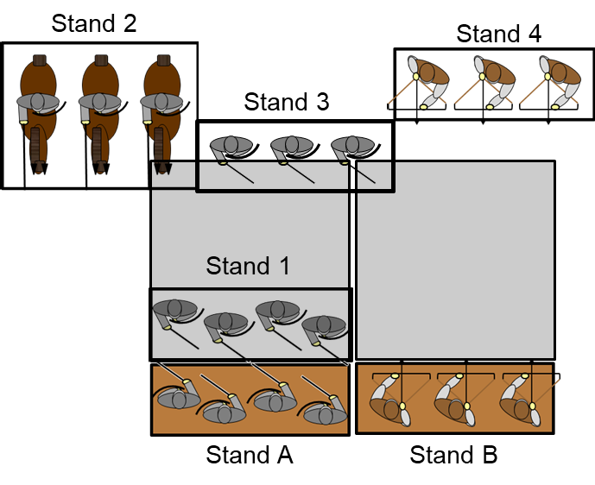
In the Diagram Stand 1 and Stand 2 are in the Threat Zone of Stand A. Stand 3 is in the Threat Zone of both Stand A and Stand B and may choose which to respond to. Stand 4 is not in any Threat Zone.

MOVING INTO CONTACT WITH ENEMY
Same as the rules for DBA 3.0. Treat a Stronghold as a BUA for contact purposes.
Contact with Aerial Elements Exceptions
Aerials can engage ground troops in close combat, but cannot be engaged in close combat by ground troops unless the Aerial is already in frontal close combat. Exception: Heroes and Paladins can engage Aerials in Close Combat. If an Aerial is not already in Close Combat or engaged by a Hero or Paladin, then the element bases, though physically touching, are not considered to be in contact for game purposes, except that Aerials can count as an overlap.
An Aerial that begins its bound already lined up in front edge contact but not yet engaged by ground troops may initiate close combat in its own bound without expending PIPs.
Once Aerials enter close combat (even with other Aerials), they remain in close combat and can be engaged by all ground troops until all physical contact other than overlaps ends.

TURNING TO FACE A FLANK OR REAR CONTACT
Same as DBA 3.0.

MAGICAL ATTACK
In Shooting Phase, a Mage element can attempt to bespell one enemy element if:
- The Mage is not in close combat contact with an enemy element
- The Mage is within 5BW of the target measured from nearest point to nearest point
- The Mage expends 2 PIPs.
Up to 2 additional Mage elements can bespell the same target at a cost of 1 PIP per additional element. The additional Mages aid the original Mage and do not resolve their attacks separately.
Mages scry their targets by magical means so can ignore intervening elements and terrain. Mages may target any enemy element in range even those in close combat.

DISTANT SHOOTING
Only these element types can use distance shooting:
- Shooters
- Bows
- Artillery
- and War Wagons
Maximum range is:
- 5 BW if Artillery
- 3 BW for all others.
Measure range between the closest points of the shooting edge and the target edge.
The Shooting Edge is:
- the front edge of a Shooter, Bow or Artillery element, or
- any 1 BW portion of the perimeter of a Stronghold or Camp if occupied by a shooting element or
- any edge of a War Wagon.

The Target Edge is:
- the entire side edge if smaller than ½ BW, or any ½ BW portion, if larger
- any ½ BW portion of an element front edge or Stronghold or Camp.
Shooting Arc
The entire target edge must be within 1BW of directly in front of one corner of the shooter’s front edge see diagram below. A target edge in contact with the front edge of the Shooting Arc is considered in the Arc but a target edge in contact with only the side edges of the Shooting Arc is not in the Arc

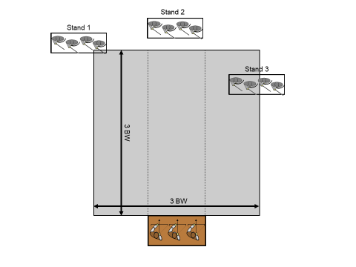
In the diagram the Bow element cannot shoot element Stand 1 because while it is in arc it is not in Range. The Bow element cannot shoot element Stand 2 because it is out of range. It can shoot at Stands 3 because they are in range and arc.
Shooting is blocked if uncrossed lines joining the ends of the shooting and target edges have part of any element between them. A hill’s crest, a Stronghold, Camp or Stronghold, or a ½ BW depth of difficult hills, woods, oasis, dunes, hamlet or edifice blocks shooting from and at an element base edge entirely beyond it. An element that is at least partly in a river or a marsh cannot shoot. An element entirely in a gully cannot shoot or be shot at.

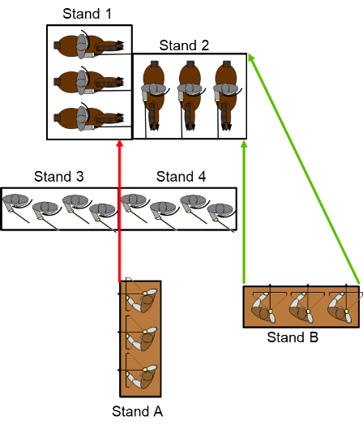
Figure 15: Blocked Stands
A shooting line that passes between two adjacent Stand corners or edges is blocked. In Figure 15, Bow A cannot shoot diagonally past Stand 3 and Stand 4 at Stand 1, because the shooting lines pass between two adjacent Stand corners. Bow B can draw a shooting line from its left front corner to the right front corner of Stand 2 diagonally just missing the right front corner of Stand B. (If there was a Stand to the right of Stand 4 and adjacent it would block this diagonal line since it then would have to pass two adjacent Stand corners.)
Elements in close combat or providing rear support cannot shoot or be shot. Elements that are overlapping and not in close combat can shoot. Targets exposed by outcome moves can be shot at.
Shooters, Bows and WWg must shoot at a target in their TZ. If there is none, they must shoot at a target that can shoot at them during this Shooting Phase. Once selected as a target, target elements must shoot back at the element shooting at them if possible. Additional elements able to shoot at a selected target element may aid shooting or select a different target. If no enemy element is in the shooter’s TZ and no element can shoot at the shooting element, it can choose any eligible target. Shooters, Bows and War Wagons that move more than 1 BW cannot shoot. Third party shooting uses the standard DBA 3.0 rules.
Artillery always chooses its target and can shoot through or over enemy Psiloi, Lurkers or Sneakers. Artillery can shoot only (a) in their own bound if they did not move, or (b) to shoot back at enemy artillery shooting at them.
Extra Elements Shooting
Same as DBA 3.0.

CLOSE COMBAT
Same as DBA 3.0 except that:
An element (except Dragons) not in frontal close combat but in mutual right-to-right or left-to-left front or rear corner contact with any enemy element except Psiloi and Sneakers overlaps it; even when the enemy element is exposed by its frontal opponent having recoiled, fled or been destroyed that bound. Any enemies in any mutual flank edge contact overlap each other whether in close combat or not. An element can overlap 2 enemy elements on opposite flanks. A Foot element that did not move this bound and has its nearest front corner less than 1 BW from a battlefield edge counts as overlapped on that corner. Only 1 overlap or flank contact is counted per flank.
Close combat against a Stronghold or Camp:
Same as DBA 3.0 except that Behemoths can assault a Stronghold only at a gate. Strongholds or unoccupied Camps use their base Combat Factor (see below).

RESOLVING BESPELLING, SHOOTING OR CLOSE COMBAT
Whether in contact, Bespelling, shooting or only shot at, each player dices for their element, and adds its Combat Factor (CF) below and any rear support, flank support and tactical factors to the score.
Troop Type | CF Against  Foot/Stronghold | CF Against  Mounted/Aerials | Special Abilities
Airboat | +5 | +3
Artillery | +4 | +4 | Shoots 5BW
Auxilia | +3 | +3
Beasts | +3 | +4 | Count Rough/Bad as Good Going
Behemoths | +5 | +4
Blades | +5 (+4 if shot at or Bespelled) | +3 | Gives Flank Support to Spears, Bows & Shooters (not Fast)
Bows | +2 | +4 | Gets Flank Support from Blades (not Fast)  Shoots 3BW
Camels | +3 | +3
Camp | +2 | +2 | Add Foot CF for any Camp garrison
Cavalry | +3 | +3
Cleric | +4 | +4
Command Post | +5 (+4 if shot at or Bespelled) | +3
Dragon | +6 | +6
Flyers | +2 | +2
God | +6 | +6 | May pass through elements
Hero | +5 | +5
Hordes | +3 | +2
Knights | +3 | +4
Light Horse | +2 | +2 | Give and get Rear Support from Light Horse
Mage | +4 | +4 | Can Bespell 5BW
Paladin | +6 | +6
Pikes | +3 | +4 | Give and get Rear Support from Pikes
Psiloi/Lurkers | +2 | +2 | Lurkers can deploy in Ambush
Scythed Chariots | +3 | +3
Shooters | +3 | +4 | Get Flank Support from Blades (not Fast)  Shoots 3BW
Sneakers | +5 | +3 | Can pass through elements
Spears | +4 | +4 | Give and get Flank Support from Spears & get from Blades (not Fast)
Warband | +3 | +2 | Give and get Rear Support from Warband
Stronghold | +4 | +4 | Add Foot CF of any garrison
War-Wagon | +3 | +4 | Shoots 3BW

Rear support factors:
Some troop types get a rear support factor when in frontal close combat if they have another friendly element of the same type lined-up directly behind facing the same direction and both are in good going.
Pikes add +3 and Warband +1 against enemy Foot other than Psiloi.
Pikes add +1 against Knights, Behemoths or Scythed Chariots.
Light Horse add +1 against all troop types.
Double elements (6Kn, 6Cv, 8Sp, 6Bd, 8Bw) entirely in good going and not in a Stronghold or Camp add +1 when in frontal close combat against enemy Foot except Strongholds.

Formation support factors:
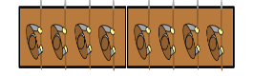
A Shieldwall Formation
Some elements add +1 when in frontal close combat in good going against Foot if at least 1 flank edge is in mutual side edge and mutual front corner contact with a friendly element. Fast elements neither give nor receive Formation support.
Spears get a +1 Shieldwall bonus if supported by Blades or Spears.
Shooters or Bows get a +1 Retinue bonus if supported by Blades.

Tactical factors for Bespelling:
Add to or subtract from scores for each of the following tactical factors that applies:
+2 If bespelled and the shortest line from the main bespeller crosses a river or passes within 5BW of any Paladin or Cleric or if being bespelled while in a Wood, Stronghold or Hamlet
+1 If the General's element and being bespelled (but not bespelling).
-1 For each 2nd or 3rd enemy Mage aiding bespelling Mage.
-2 If bespelling an enemy Mage who is within 5BW of his/her own Stronghold.

Tactical factors for Shooting:
Add to or subtract from scores for each of the following tactical factors that applies:
+4 If occupying a Stronghold and being shot at.
+2 If occupying a Camp and being shot at.
+1 If the General's element and being shot at.
-1 For each 2nd or 3rd enemy element aiding opposing element’s shooting.

Tactical factors for Close Combat:
Add to or subtract from scores for each of the following tactical factors that applies:
+4 If occupying a Stronghold.
+2 If occupying a Camp.
+1 If the General's element.
+1 If uphill or defending any but a paltry river’s bank off-road unless either element is an Aerial.
-1 For each enemy element either overlapping or in front edge and front corner-to-front corner contact with flank.
–1 If an enemy element is in full front edge contact with rear.
-2 If any troops except Auxilia, Bows, Warband, Beasts, Shooters or Psiloi and in Bad (not Rough) Going.

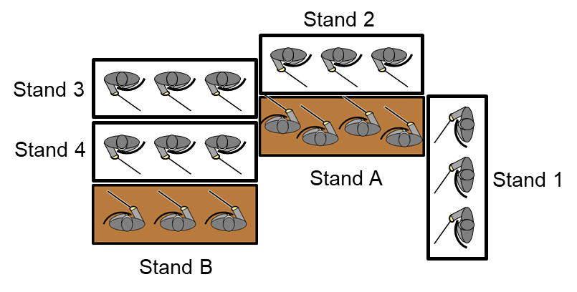
Flank Modifier Example
Example Overlap and Flanking Modifiers
In the diagram below Stand 1 Hard Flanks the Heavy Foot Stand B. Stand 3 Overlaps the Heavy Foot Stand A for a total modifier of -2 (and no Recoil due to Stand 1). Stand 4 also Overlaps the Heavy Foot Stand A but you can only count one Overlap modifier per side so it has no additional effect. The Heavy Foot Stand A Overlaps Stand 4 giving it a -1 modifier against the Medium Foot Stand B.

COMBAT OUTCOME
An element whose total is equal to or less than that of its opponent may need to make an immediate outcome move, which depends on its own type and that of the opponent in close combat with its front edge or shooting at it. Elements shooting or Bespelling without being shot at or Bespelled disregard an unfavourable outcome. (Exception: elements Bespelling Gods do not disregard unfavourable outcomes). Elements (other than a General, Stronghold or other Sneakers) in Close Combat with Sneakers disregard unfavourable outcomes. Elements in close combat against an enemy element’s flank or rear Recoil if a friendly element in combat with its front Recoils, Flees or is Destroyed or Ensorcelled.
If its total is equal to that of its opponent:
No effect if attacking or defending a Stronghold or Camp. If not:
Hero v. Hero Both destroyed if both totals are odd. Otherwise no effect.
Paladin v. Mage Both destroyed if in close combat and both totals are odd. Otherwise no effect.
Scythed Chariots Destroyed.
Fast Knights Destroyed in close combat by Blades or Shooters. If not Destroyed, Recoiled in close combat unless opponent also Fast and from shooting. Otherwise no effect.
Other Knights & Camelry Destroyed in close combat by Blades or Shooters. If not Destroyed, Recoiled in close combat unless opponent Fast and from all shooting. 4Kn Recoiled by 3Kn. Otherwise no effect.

Other Fast. Recoiled in close combat unless opponent also Fast and from all shooting. Otherwise no effect.
Other Mounted (not Fast) Recoiled by Foot (except Fast) in close combat. Otherwise no effect.
Other Foot (not Fast) Destroyed by Foot if a Command Post in contact on 2 or more edges by enemy front edges. Otherwise no effect.

If its total is less than that of its opponent but more than half:
Destroyed if Mounted Infantry in bad going. No effect if Command Post. Otherwise:
Behemoths Unless Fast, Destroyed by Psiloi, Auxilia or Light Horse. Flee from Mage, Dragon or Artillery shooting. Otherwise Recoil.
Airboats, Flyers Flee from Mage. Otherwise Recoil.
Dragons Destroyed by Hero or Paladin. If not Flee.
Gods Flee from God, Mage or Cleric. If not no effect.
Paladins Destroyed if in close combat. If not no effect.
Hero Ensorcelled by Mage. Destroyed by Hero, Paladin or Artillery shooting. Flee from Stronghold. Otherwise Recoil.
Mage Ensorcelled by Mage. Destroyed by Hero, Paladin, Dragon or God. Otherwise Recoil.
Scythed Chariots Flee if shot at unless at least partly on their rear edge. If not, destroyed.
Knights Destroyed by Behemoths, Scythed Chariots, Camelry or Light Horse. Otherwise Recoil.
Camelry Destroyed by Scythed Chariots or if themselves in bad going. Flee from Behemoths, otherwise Recoil.
Cavalry Flee from Scythed Chariots, or if in bad going. Otherwise Recoil.
Light Horse Flee from Scythed Chariots, Artillery shooting, or if in bad going. Otherwise Recoil.
Spears, Pikes, or Blades Destroyed by Knights or Scythed Chariots if in good going or by Warband. Otherwise Recoil.
Cleric Destroyed by Knights or Scythed Chariots if in good going or by Warband. Otherwise Recoil.
Auxilia Destroyed by Knights if in good going. Otherwise Recoil.
Bows, Beasts, Shooters Destroyed by any mounted. Otherwise Recoil.
Psiloi, Lurkers Destroyed by Knights, Cavalry or Camelry in going which to the opponent is good. Otherwise Recoil.
Sneakers Flee.
Warband Destroyed by Knights, Fast Behemoths or Scythed Chariots if in good going. Otherwise Recoil.
Hordes Destroyed by Knights or Behemoths in good going, or by Warband. Recoil if shot at. If not, no effect.
War Wagons Destroyed by Artillery shooting or by Behemoths. If not, no effect.
Camp, Stronghold Captured if any ground troops in contact. If not, no effect.
Artillery Destroyed.

If its total is half or less than half that of its opponent:
Destroyed if defenders of a Stronghold or Camp. If not:
Cavalry Flee from Pikes, Spears or Hordes if in good going or Artillery in close combat. If not, destroyed.
Light Horse Destroyed by any mounted, Artillery shooting, Bows, Shooters or Psiloi, or if in bad going. If not, flee.
Psiloi Flee from shooting. Recoil from Behemoths or Scythed Chariots. Destroyed by other Mounted or Aerials if in going these count as good. Destroyed in close combat against Auxilia, Bows, Shooters or Psiloi. Flee from other Foot.
Flyers Destroyed by Hero, Mage, Aerials, Shooters or Bow. If not, Flee.
All others Destroyed.

ENSORCELLED ELEMENTS
A Hero or Mage Ensorcelled by a hostile Mage is temporally removed until desorcelled by expenditure of 6 PIPs or the destruction, Ensorcellement or Fleeing of the bespeller.
A Mage who scores an unmodified “1” with a Bespelling dice for the second time in a game is self-Ensorcelled. (This does not affect Mages aiding the Bespellment.) A self-Ensorcelled Mage can only be desorcelled by the expenditure of 6 PIPs. However Ensorcelled, replace the base of an Ensorcelled Mage with a flat maker of the same size showing facing. This marker has no effect on game play except to mark where a de-Ensorcelled Mage will reappear. Any friendly or enemy element covering any part of this maker will prevent the desorcelling of that Mage.

DESTROYED ELEMENTS
Same as the rules for DBA 3.0 – see that section in the DBA 3.0 rules.

RECOILING
This represents troops falling back a short distance under enemy pressure while continuing to maintain formation and fight. A Recoiling element moves straight back without turning:
A Foot element always moves its own base depth or ½ BW if this is less than its base depth.
A Mounted or Aerial element can choose to either to move 1 BW or to move its own base depth if this is less than 1 BW.
An element with a Recoil outcome to shooting at least partially on its rear edge, turns to face its rear before Recoiling.
Recoilers can pass through friends facing in exactly the same direction to a clear space immediately behind the first element met, but only if:
(a) Mounted troops Recoiling into any friends except Pikes, Hordes, or Behemoths,
(b) Blades Recoiling into Blades or Spears,
(c) Pike, Shooters or Bows Recoiling into Blades, or
(d) Psiloi Recoiling into any friends except Psiloi.
If the Recoiling element is not Behemoths, friends facing in the same direction are passed through if allowed as above. If pass through is not allowed, friends facing in exactly the same direction (except War-Wagons and Behemoths) are pushed back far enough to make room for the Recoil. Pushed back elements cannot pass through or push back others and therefore prevent Recoil.
If the Recoiling element is a Behemoth, all friends or enemy Recoiled into (not just touching) except Strongholds or Camps are destroyed. Behemoths Recoiling from close combat against the defenders of a Stronghold are destroyed. If a Behemoth is Recoiled into, both are destroyed. Surviving Behemoths finish their recoil.
A Recoiling or pushed back element whose rear edge or rear corner meets terrain it cannot enter, a battlefield edge, friends it cannot pass through or push back, enemy or a Stronghold or Camp ends its move there. A Recoiling or pushed back element that is already in such contact with any of these or that starts with enemy in front edge contact with its flank, rear or rear corner cannot Recoil and is destroyed instead.

FLEEING
This represents a panic individual rush to the rear. A Fleeing element turns 180 degrees in place; and then moves straight forward without turning for its full tactical move distance for the going it starts in. It then halts until making a tactical move or conforming to further contact by enemy. If it contacts a side battlefield edge, it pivots and continues the move along that edge towards its rear battlefield edge. If any part of it crosses any other battlefield edge it is removed as lost. Exception: an element with a Flee outcome to shooting at least partially on its rear edge, does not turn 180 degrees before moving but just Flees straight forward.
It stops before completing its move and lines up if its front edge (or front corner only) contacts any of: (a) enemy (whom it will fight next bound), (b) friends it cannot pass through (c) a Stronghold or Camp, (d) a waterway, or (e) for troops other than Psiloi or Light Horse, any bad going except marsh it is not already at least partly in.
It is destroyed if it starts with an enemy front edge in contact with its flank or rear edges, or if after turning it cannot move at all, or if it enters any river. If a friendly or enemy element prevents further movement by fleeing Behemoths or Scythed Chariots, both elements are destroyed.

PURSUING
This represents following up a retiring close combat opponent or panicked survivors of a destroyed element with the intention of continuing to kill them. An element (and all elements in column behind it) whose close combat opponents recoil (from either close combat or bespelling), flee or are destroyed must immediately pursue, if:
(a) It destroyed the defenders of a Stronghold or Camp in close combat. It immediately moves into that feature.
(b) It is Knights (other than 4Kn or fighting Lurker/Ps), Scythed Chariots, Behemoths, Beasts or Hordes. It pursues 1 BW straight ahead.
(c) It is Pikes, Blades or Warband that fought against Foot (other than Lurker/Psiloi). It pursues ½ BW straight ahead.
Exception: An element of any type does not pursue if it is in a Stronghold or Camp, or if its potential pursuit move would cross a battlefield edge or enter going it counts as Bad other than Marsh or Gully.
If a pursuing element’s front edge contacts enemy or its front corner contacts an enemy front edge, it or they line up immediately as if contact was by a tactical move, but the resulting combat is resolved next bound.

WINNING AND LOSING THE BATTLE
The first side which has lost at the end of a bound 12 Army Points and more points than the enemy loses the battle. Each lost element counts as its AP cost. A General’s element lost during the battle counts as the cost of that element plus 2 AP. A sacked Camp counts as 2 AP lost. A fallen Stronghold counts as 4 AP lost.
An element is lost if it:
- has been Destroyed,
- is currently Ensorcelled or
- has Recoiled or Fled across a battlefield edge.
A God, Dragon or Lurker that has not been deployed does not count as lost. Elements that are Ensorcelled count as lost until returned to the battle. Similarly destroyed Inexhaustible Hordes count as lost until returned to the battle. Elements that have Fled off the battlefield count as lost until returned (if possible). Those that crossed a battlefield edge and are only lost for this battle and will reappear in the next turn of a campaign.

Credits:
Rules written by Phil Barker
Edited and compiled by Thomas J. Thomas, Fame & Glory Games
Send playtest comments to: TomAndKate@aol.com
Spelling correction, re-setting, and spacing modified by Jason Abels (no rights requested, assumed, or implied) – 8/2/2016

Type | Against Foot, Camp, Stronghold | Against Mounted & Aerials | Movement |  | Bad Going
Generally | Recoil if More; Destroyed if Doubled | Recoil if More; Kill if Doubled | Good Going | Rough & Bad
All | Kill Art on More in CC  Unless Fast Recoil Fast on Equal  Flee Sneakers on More | Kill Paladins on More in CC  Unless Fast Recoil All on Equal  (Exception: Shooters & Blade Destroy Kn)
Artillery | +4; Shooting Range 5BW  Flee Doubled Psiloi  Destroy War Wagon on More if Shooting | +4; Shooting Range 5BW  Flee Light Horse & Flyers on More if Shooting  Destroy Behemoth & Hero on More if Shooting  Flee Doubled Cav, Light Horse & Flyers in CC | 2 | -- | No Go
AIRBOAT | +5 | +3 | 5 | 5 | Cannot land in Woods/BUA
Auxilia | +3 | +3 | 2/Fast 3 | 2/Fast 3 | --
Beasts | +3; Pursue; Destory Bow & Shooters on More | +4 Pursue | 4 | 4 | --
Behemoth | +5; Pursue; Destroy Bows, Shooters & Hordes on More; Recoil Doubled Psiloi | +4; Pursue; Kill Knight & Beasts on More  Recoil Doubled Flyers | 3/Fast 4 | 1 | -2
Blade | +5 (+4 v. Shooting, bespelling); Pursue (not Psiloi)  Flee Doubled Psiloi | +3; Kill Kn on Equals  Flee Doubled Light Horse & Flyers | 2/Fast 3 | 1/Fast 3 | -2
Bow | +2; Shooting Range 3BW  +3 with Blade Side Support (not Fast) in CC  Flee Doubled Psiloi if shooting | +4; Shooting Range 3BW | 2/Fast 3 | 1/Fast 3 | No Side Support
Camels | +3; Destroy Psiloi on More in Good  Destroy Bow & Shooters on More | +3; Kill Kn & Beasts on More  Flee Behemoth (not Fast) on More | 3 | 1 | Killed on More by All  Dune & Oasis = Good Going
Cavalry (Cav) | +3; Kill all Bow & Shooters on More | +3; Kill Beasts on More | 4/Fast 5 | 1 | -2; Flee on More by All
Cleric | +4 | +4; Flee Gods on More | 2 | 1 | -2
Command Post | +5 (+4 v. Shooting, bespelling); No Recoil | +3; No Recoil | 2 | -- | No Go
DRAGON | +6; Kill Mage on More | +6; Flee Behemoths on More | 10 | 10 | Cannot land in Woods/BUA
FLYER | +2 | +2 | 10 | 10 | Cannot land in Woods/BUA
GOD | +6; No Recoil; Kill Mage on More | +6; No Recoil; Flee Gods on More | 10 | 10 | Cannot land in Woods/BUA
Hero | +5; Kill Bows, Mage & Shooters on More | +5; Kill Hero, Dragons & Beasts on More | 5 (10 if Flyer) | 1 (10 if Flyer) | -2 Flyer cannot land as above
Hordes | +3 (No Recoil in CC); Pursue  Flee Doubled Psiloi | +2 (No Recoil); Pursue  Flee Doubled Cav, Light Horse & Flyers | 2/Fast 3 | 1/Fast 3 | -2
Knight | +3; Pursue; Destroy Bows & Shooters on More  Kill all other Foot (not War Wagon) on More in Good | +4; Pursue  Destroy Beasts on More | 3 | 1 | -2  Killed on More by All
Light Horse | +2; +3 Rear Support from Light Horse ; Kill Bow & Shooters on More | +2; +3 Rear Support from Light Horse  Kill Kn on More | 4 (March) | 1 | -2
Mage | +4; Spell Cast 5BW  Ensorcell Mage on More | +4; Spell Cast 5BW; Ensorcell Hero on More  Flee Behemoths, Gods & Flyers on More | 5 | 1 | -2
Paladin | +6; Kill Bows, Mage & Shooters on More | +6; Kill Hero on More | 5 | 1 | -2
Pike | +3; +6 with Rear Support in CC; Pursue (not Psiloi)  Flee Doubled Psiloi | +4; +5 with Rear Support in CC;  Flee Doubled Cav, Light horse & Flyers in Good | 2/Fast 3 | 1/Fast 3 | -2 & No Rear Support
Psiloi | +2 | +2; Kill Behemoth (not Fast) on More | Fast 3 | Fast 3
Shooters | +3; Shooting Range 3BW  +4 in CC with Blade Side Support (not Fast)  Flee Doubled Ps if shooting | +4; Shooting Range 3BW  Kill Kn on Equal in CC | 2/Fast 3 | 1 /Fast 3 | No Side Support
Sneaker | +5 (Effect only Gen, Stronghold, Camp or Sneeker) | +3 (Effect only Gen) | Fast 3 | Fast 3
Spear | +4; +5 with Side Support from Spear or Blade in CC  Flee Doubled Psiloi | +4; Flee Doubled Cav, Light Horse & Flyers in Good | 2 | 1 | -2 & No Side Support
Warband | +3; +4 with Rear Support in CC  Kill Blades, Hordes, Pikes & Spears on More  Flee Doubled Psiloi; Pursue (only foot not Psiloi ) | +2; Flee Doubled Cav, Light Horse & Flyers in Good | 2/Fast 3 | 1/Fast 3 | No Rear Support
War Wagon | +3; Shooting Range 3BW; No Recoil | +4; Shooting Range 3BW; No Recoil | 2/Fast 3 | -- | No Go

Terrain and Set Up
If terrain is: | Compulsory | Optional Linear | Optional Rough | Optional Bad Going | Optional Others
ARABLE | 1 BUA  or  2 Plough | River (1 only)  Road  Waterway (1 only) | Enclosures  Scrub  Boggy | Difficult Hills  Woods | Gentle Hills  Plough
FOREST | 1-2 Woods | River (1 only) |  | Marsh  Woods | Gentle Hills  BUA (1 only)
HILLY | 1-2 Difficult Hills | River (1 only)  Road |  | Woods  Difficult Hills | BUA (1 only)
STEPPE | 1-2 Gentle Hills | River (1 only)  Gully (1 only) | Scrub  Rocky |  | BUA (1 only)
DRY | 1-2 Rocky  or  1-2 Scrub |  |  | Dunes  Difficult Hills  Oasis (1 only) | BUA (1 only)
TROPICAL | 1-2 Woods | River (1 only)  Gully (1 only)  Road | Enclosures | Marsh  Woods | BUA (1 only)
LITTORAL | 1 Waterway | Road  River (1 only) |  | Difficult Hills or Marsh  Woods or Dunes | BUA (1 only)

Tactical Factors

Tactical factors for Bespelling:
Add to or subtract from scores for each of the following tactical factors that applies:
+2 If bespelled and the shortest line from the main bespeller crosses a River.
OR If bespelled and the shortest line from the main bespeller passes within 5BW of any Paladin or Cleric.
OR If being bespelled while in a Wood, Stronghold or Hamlet.
+1 If the general's element and being bespelled (but not bespelling).
-1 For each 2nd or 3rd enemy Mage aiding bespelling Mage.
-2 If bespelling an enemy Mage within 5BW of their own Stronghold.

Tactical factors for Shooting:
Add to or subtract from scores for each of the following tactical factors that applies:
+4 If occupying a Stronghold and being shot at.
+2 If occupying a Camp and being shot at.
+1 If the general's element and being shot at.
-1 For each 2nd or 3rd enemy element aiding opposing element’s shooting.

Tactical factors for Close Combat:
Add to or subtract from scores for each of the following tactical factors that applies:
+4 If occupying a Stronghold.
+2 If occupying a Camp.
+1 Shieldwall
+1 Retinue
+1 If the general's element.
+1 If uphill or defending any but a paltry river’s bank off-road unless either element is an Aerial.
-1 For each enemy element either Overlapping or in front edge and front corner-to-front corner contact with flank.
-1 Enemy Element in front edge contact w/rear.
-2 If any troops but Auxilia, Bows, Warband, Lurkers, Beasts, Shooters or Psiloi and in Bad
COMBAT OUTCOME (Traditional HOTT only)
An element whose total is equal to or less than that of its opponent may need to make an immediate outcome move, which depends on its own type and that of the opponent in close combat with its front edge or shooting at it. Elements shooting or Bespelling without being shot at or Bespelled disregard an unfavourable outcome. (Exception: elements Bespelling Gods do not disregard unfavourable outcomes). Elements (other than a General, Stronghold or other Sneakers) in Close Combat with Sneakers disregard unfavourable outcomes. Elements in close combat against an enemy element’s flank or rear Recoil if a friendly element in combat with its front Recoils, Flees or is Destroyed or Ensorcelled.
If its total is equal to that of its opponent:
No effect if attacking or defending a Stronghold or Camp. If not:
Hero v. Hero Both destroyed if both totals are odd. Otherwise no effect.
Paladin v. Mage Both destroyed if in close combat and both totals are odd. Otherwise no effect.
Fast Knights Destroyed in close combat by Blades (except Fast) or Shooters (except Fast). If not Destroyed, Recoiled in close combat unless opponent also Fast and from all shooting. Otherwise no effect.
Other Knights Destroyed in close combat by Blades or Shooters. If not Destroyed, Recoiled by Foot (except Fast). Otherwise no effect.
Other Fast Recoiled in close combat unless opponent also Fast and from all shooting. Otherwise no effect.
Other Mounted (not Fast) Recoiled by Foot (except Fast) in close combat. Otherwise no effect.
Other Foot (not Fast) No effect.

If its total is less than that of its opponent but more than half:
Stronghold, Camp Destroyed if any ground troops in contact. If not, no effect.
Behemoths. Flee from Mage, Dragon or Artillery shooting. Otherwise Recoil.
Airboats, Flyers Flee from Mage. Otherwise Recoil.
Dragons Destroyed by Hero or Paladin. If not Flee.
Gods Flee from God, Mage or Cleric. If not no effect.
Paladins Destroyed if in close combat. If not no effect.
Hero Ensorcelled by Mage. Destroyed by Hero, Paladin or Artillery shooting. Flee from Stronghold.
Otherwise Recoil.
Mage Ensorcelled by Mage. Destroyed by Hero, Paladin, Dragon or God. Otherwise Recoil.
Knights Destroyed by Behemoths. Otherwise Recoil.
Cavalry Flee if in bad going. Otherwise Recoil.
Spears or Blades Destroyed by Knights if in good going or by Warband. Otherwise Recoil.
Cleric Destroyed by Knights if in good going or by Warband. Otherwise Recoil.
Beasts, Shooters Destroyed by any mounted. Otherwise Recoil.
Sneakers Flee.
Lurkers Destroyed by Knights, Cavalry or Camelry in going which to the opponent is good. Otherwise Recoil.
Warband Destroyed by Knights, Fast Behemoths if in good going. Otherwise Recoil.
Hordes Destroyed by Knights or Behemoths in good going, or by Warband. Recoil if shot at. If not, no effect.
Artillery Destroyed.

If its total is half or less than half that of its opponent:
Destroyed if defenders of a Stronghold or Camp. If not:
Cavalry Flee from Spears or Hordes if in good going or Artillery in close combat. If not, destroyed.
Flyers Destroyed by Hero, Mage, Aerials, Shooters. If not, Flee.
Lurkers Flee from shooting. Recoil from Behemoths. Destroyed by other Mounted or Aerials if in going these count as good. Destroyed in close combat against Shooters. Flee from other Foot.
All others Destroyed.

RESOLVING BESPELLING, SHOOTING OR CLOSE COMBAT (Traditional HOTT)
Whether in contact, Bespelling, shooting or only shot at, each player dices for their element, and adds its Combat Factor (CF) below and any rear support, flank support and tactical factors to the score.

Troop Type | CF Against  Foot/Stronghold | CF Against  Mounted/Aerials | Special Abilities
Airboat | +5 | +3
Artillery | +4 | +4 | Shoots 5BW
Beasts | +3 | +4 | Treat Bad/Difficult as Good Going
Behemoths | +5 | +4
Blades | +5 (+4 if shot at or Bespelled) | +3 | Gives Flank Support to Spears & Shooters (not Fast)
Cavalry | +3 | +3
Cleric | +4 | +4
Dragon | +6 | +6
Flyers | +2 | +2
God | +6 | +6
Hero | +5 | +5
Hordes | +3 | +2
Knights | +3 | +4
Mage | +4 | +4 | Can Bespell 5BW
Paladin | +6 | +6
Lurker | +2 | +2
Shooters | +3 | +4 | Gets Flank Support from Blades (not Fast)  Shoots 3BW
Sneakers | +5 | +3 | Can pass through elements
Spears | +4 | +4 | Gives and gets Flank Support from Spears & gets from Blades (not Fast)
Stronghold | +4 | +4 | Add Foot CF of any garrison
Warband | +3 | +2 | Gives and gets Rear Support from Warband

Rear support factors:
Some troop types get a rear support factor when in frontal close combat if they have another friendly element of the same type lined-up directly behind facing the same direction and both are in good going.
Warband +1 against enemy Foot.
Formation support factors:
Some elements add +1 when in frontal close combat in good going against Foot if at least 1 flank edge is in mutual side edge and mutual front corner contact with a friendly element. Fast elements neither give nor receive Formation support.
Spears get a +1 Shieldwall bonus if supported by Blades or Spears.
Shooters or Bows get a +1 Retinue bonus if supported by Blades.

